**INFO6210 15165**

**Data Management and Database Design**

**SECTION 06 - Fall 2017**

**Rohan Digamber Naik**

**NUID: 001824278**

**12/12/2017**

**Railway Operations Management System**

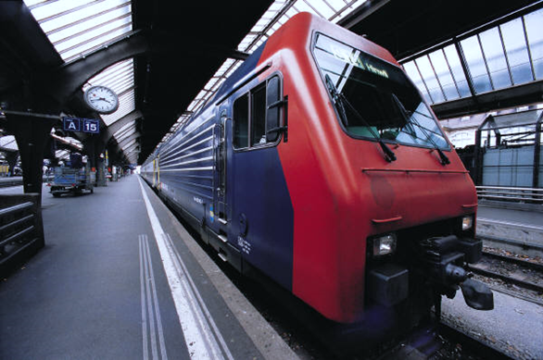

***Tables of Contents:***

1. Overview
2. Scope
3. Objective
4. Database Definitions
5. Entities of Concern
6. Relationship between entities
7. Entity-Relationship model of the database
8. Features of the Railway Operations Management system
9. Appendix

***Overview:***

The online railway management system is basically a holistic system to track the trains that ply on the routes and also to maintain a repository of the ticket bookings that are made for each trains on each route. India has a vast network of railways and there is a need of a system that can track both the reservations and train services. Taking into consideration the large amount of train services and passenger data it is imperative to consolidate and store the data in a database.

***Scope:***

Railway operations management system is broadly classified into railway enquiry system, tickets reservation system, repairs and maintenance system. The system provides a functionality to passengers to add themselves to the view the train listings. The user can also update their personal details in the system.

The system performs functions like providing the best options of the available trains from a specified source and the destination to the passengers. The train details has comprehensive information like train number, train name, train type, available class types along with respective fares, the frequency of the train during the week, seat availability, route and stoppage details and total distance and total time taken for the journey.

Passengers can book their tickets based on their preference and availability. The system also provides a functionality to the passenger to cancel their tickets. At the end of both the transactions the state of the database is restored to its original state.

The super admin of the user can add, update and delete new trains from the system, manage stations and route details and also manage passengers.

***Objective:***

Managing the Railway Operations Management System has got a technology side to it. With millions of data to be managed, designing a database system that is extremely efficient, redundant-free, cost and time efficient is imperative. The objective of this project is to design such a database having increased accountability, centralized control, integration, redundant-free, enhanced quality of outputs and better revenue management.

***Database Definitions:***

The following are the key components of the Railway Operations Management System.

***Entities of Concern:***

**Passenger:** This table includes information about the passenger who would be travelling such as name, contact details, age.

**Ticket:** This table includes passenger details corresponding to the specific source and destination, date of journey and any relevant seat preference.

**Station:** This table contains the station name and station IDs.

**Route:** This table contains the route number, distance between stations, number of trains running on this route, train arrival and departure times.

**Train:** This table contains train name, train number, train type, seats availability.

**Train Booking Status:** This table contains train availability details, seats availability status, train running status.

**Department:** This table contains the department details of the various railway employees.

**Railway Expenses:** This table contains the details of the railway expenses.

**Repairs:** This table contains the various repairs carried out by the railways department.

**Earnings:** This table contains the total earnings from the tickets sold over the period of time.

***Relationship Between entities:***

|  |  |  |  |
| --- | --- | --- | --- |
| **Sr. No.** | **Relation Type** | **Entities Involved** | **Entity Relationship** |
| 1. | Enquires | Passenger, Train | One passenger to many trains |
| 2. | Consists of | Station, Route | One route to many stations |
| 3. | Has a | Train, Train_Status | One train to one train station |
| 4. | Checks | User, Train_Status | One user to one train status |
| 5. | Has a | Train, Route | One Train to Many routes |
| 6. | Starts from, Ends on | Train, Station | One train to one station |
| 7. | Has a | Department, employees | One employee to one department |
| 8. | Has a | Zonal Offices, Departments | One department to one zonal office |
| 9. | consists of | Repairs, Expenses | One Repairs to many expenses |
| 10. | Consists of | Budget, earnings | One Budget to many earnings |

***Entity – Relationship model of the Database:***

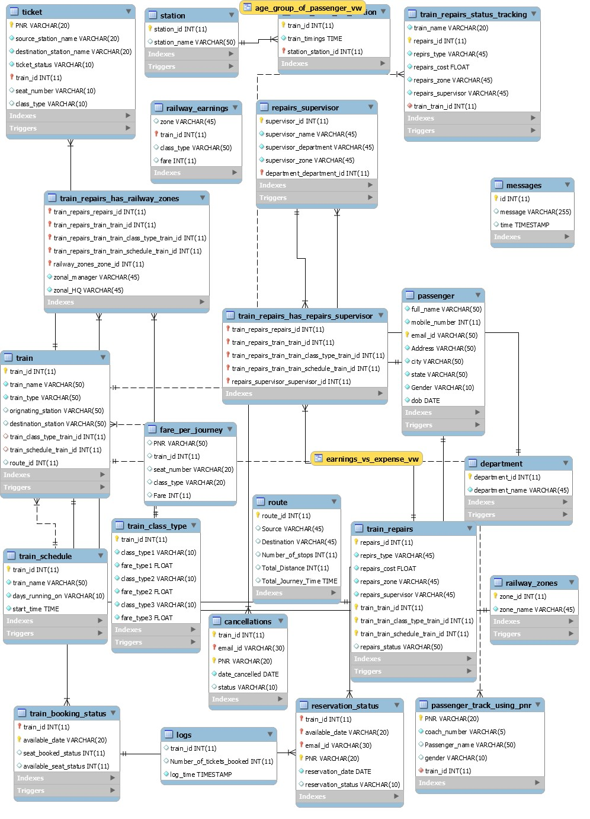

**Features of the Railway Operation Management System.**

**1.) Ticket Booking stored procedure**

The following procedure books the tickets based on the user preference. It also simultaneously updates the status tables.

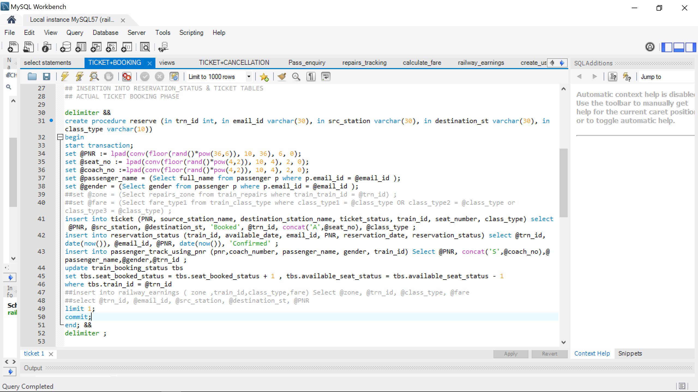

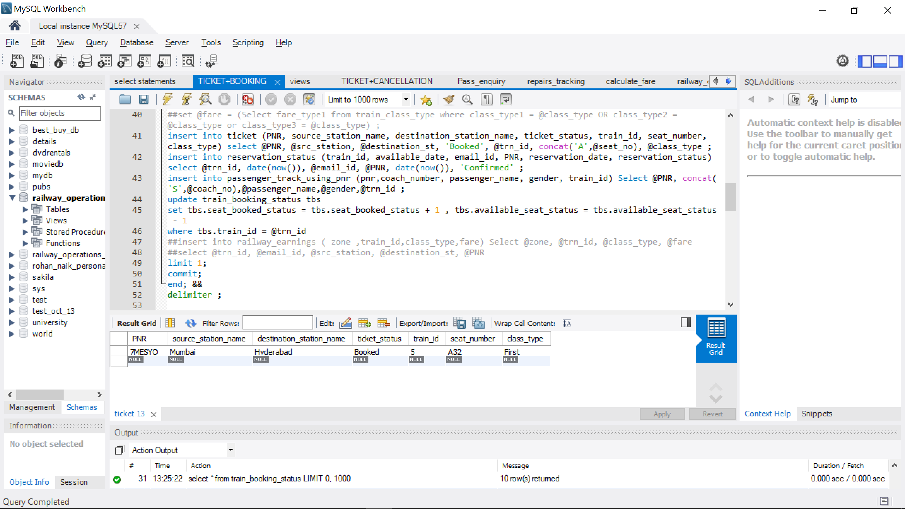

**2.) Ticket Cancellation**

This procedure cancels the ticket booked by the user.

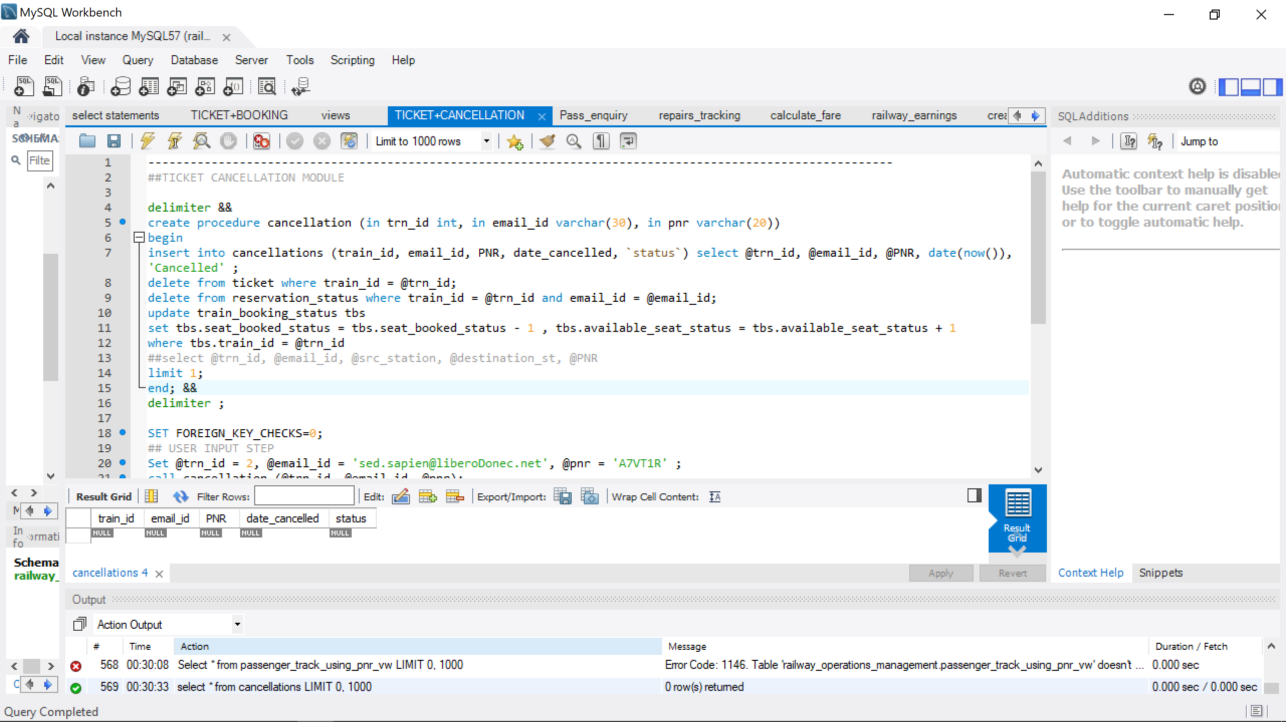

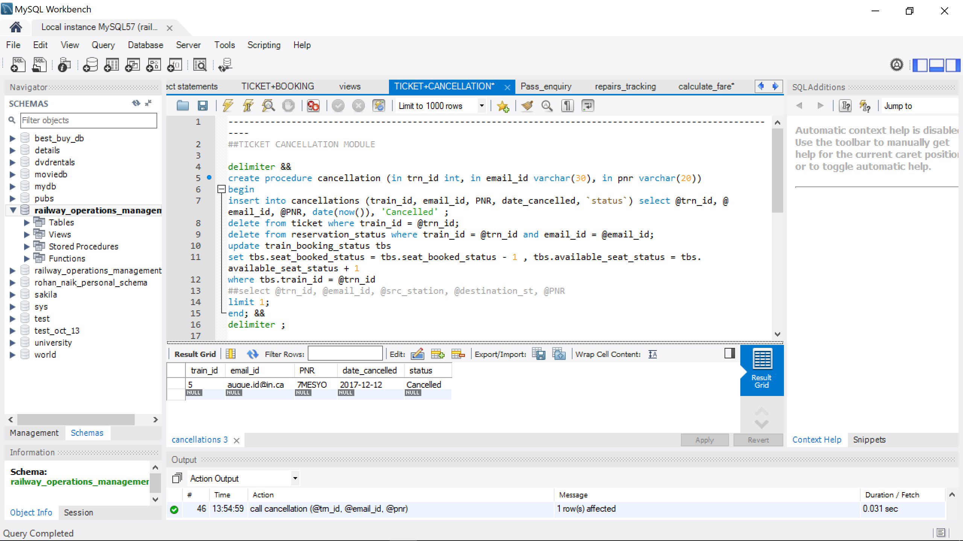

**3.) Train Enquiry Module**

The following procedure gives the details of all the available trains to the users

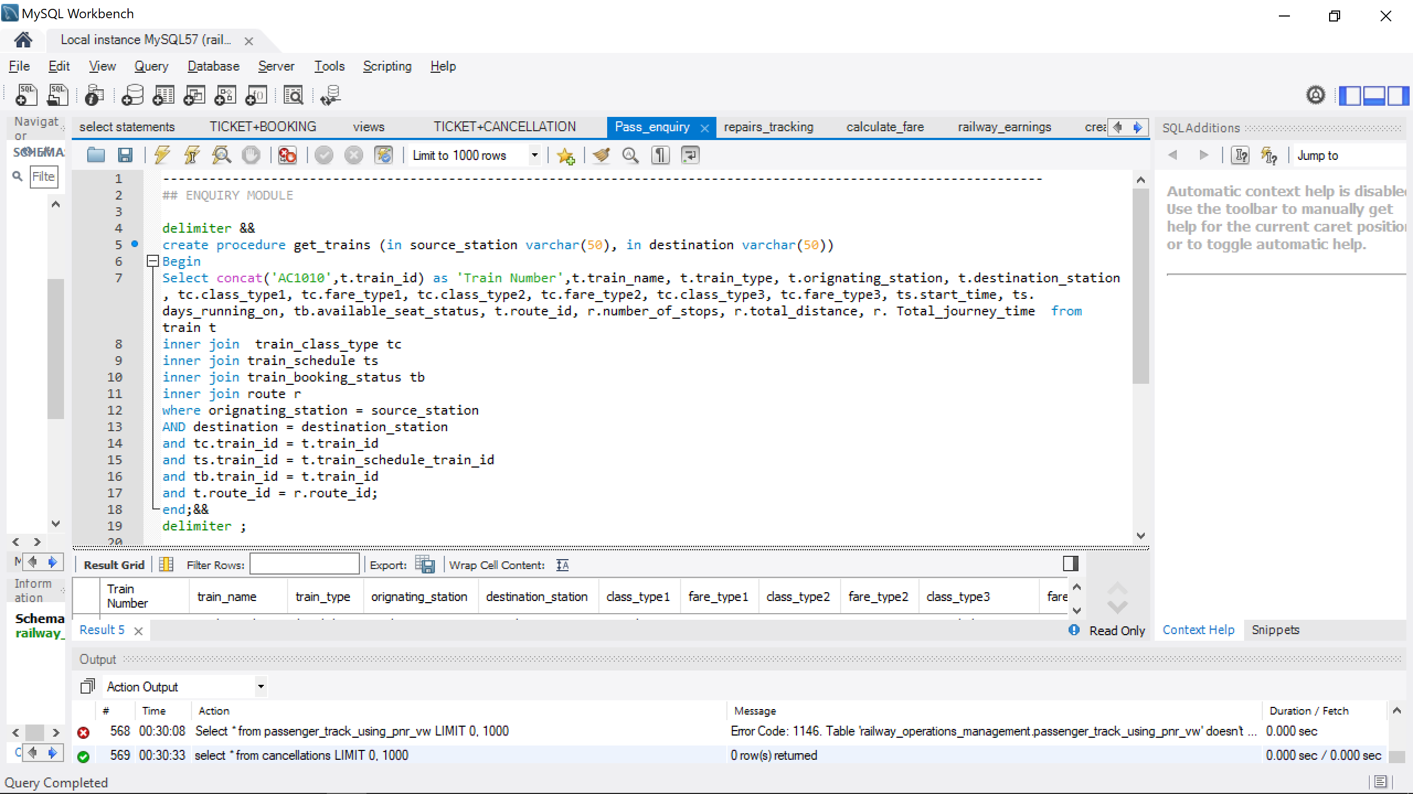

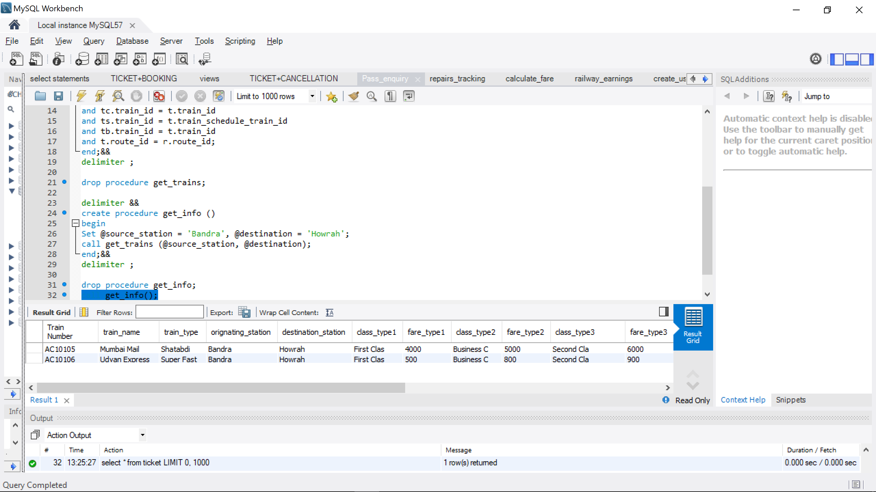

**4.) Train Repairs details**

The following procedure gives the repairs details for a particular train.

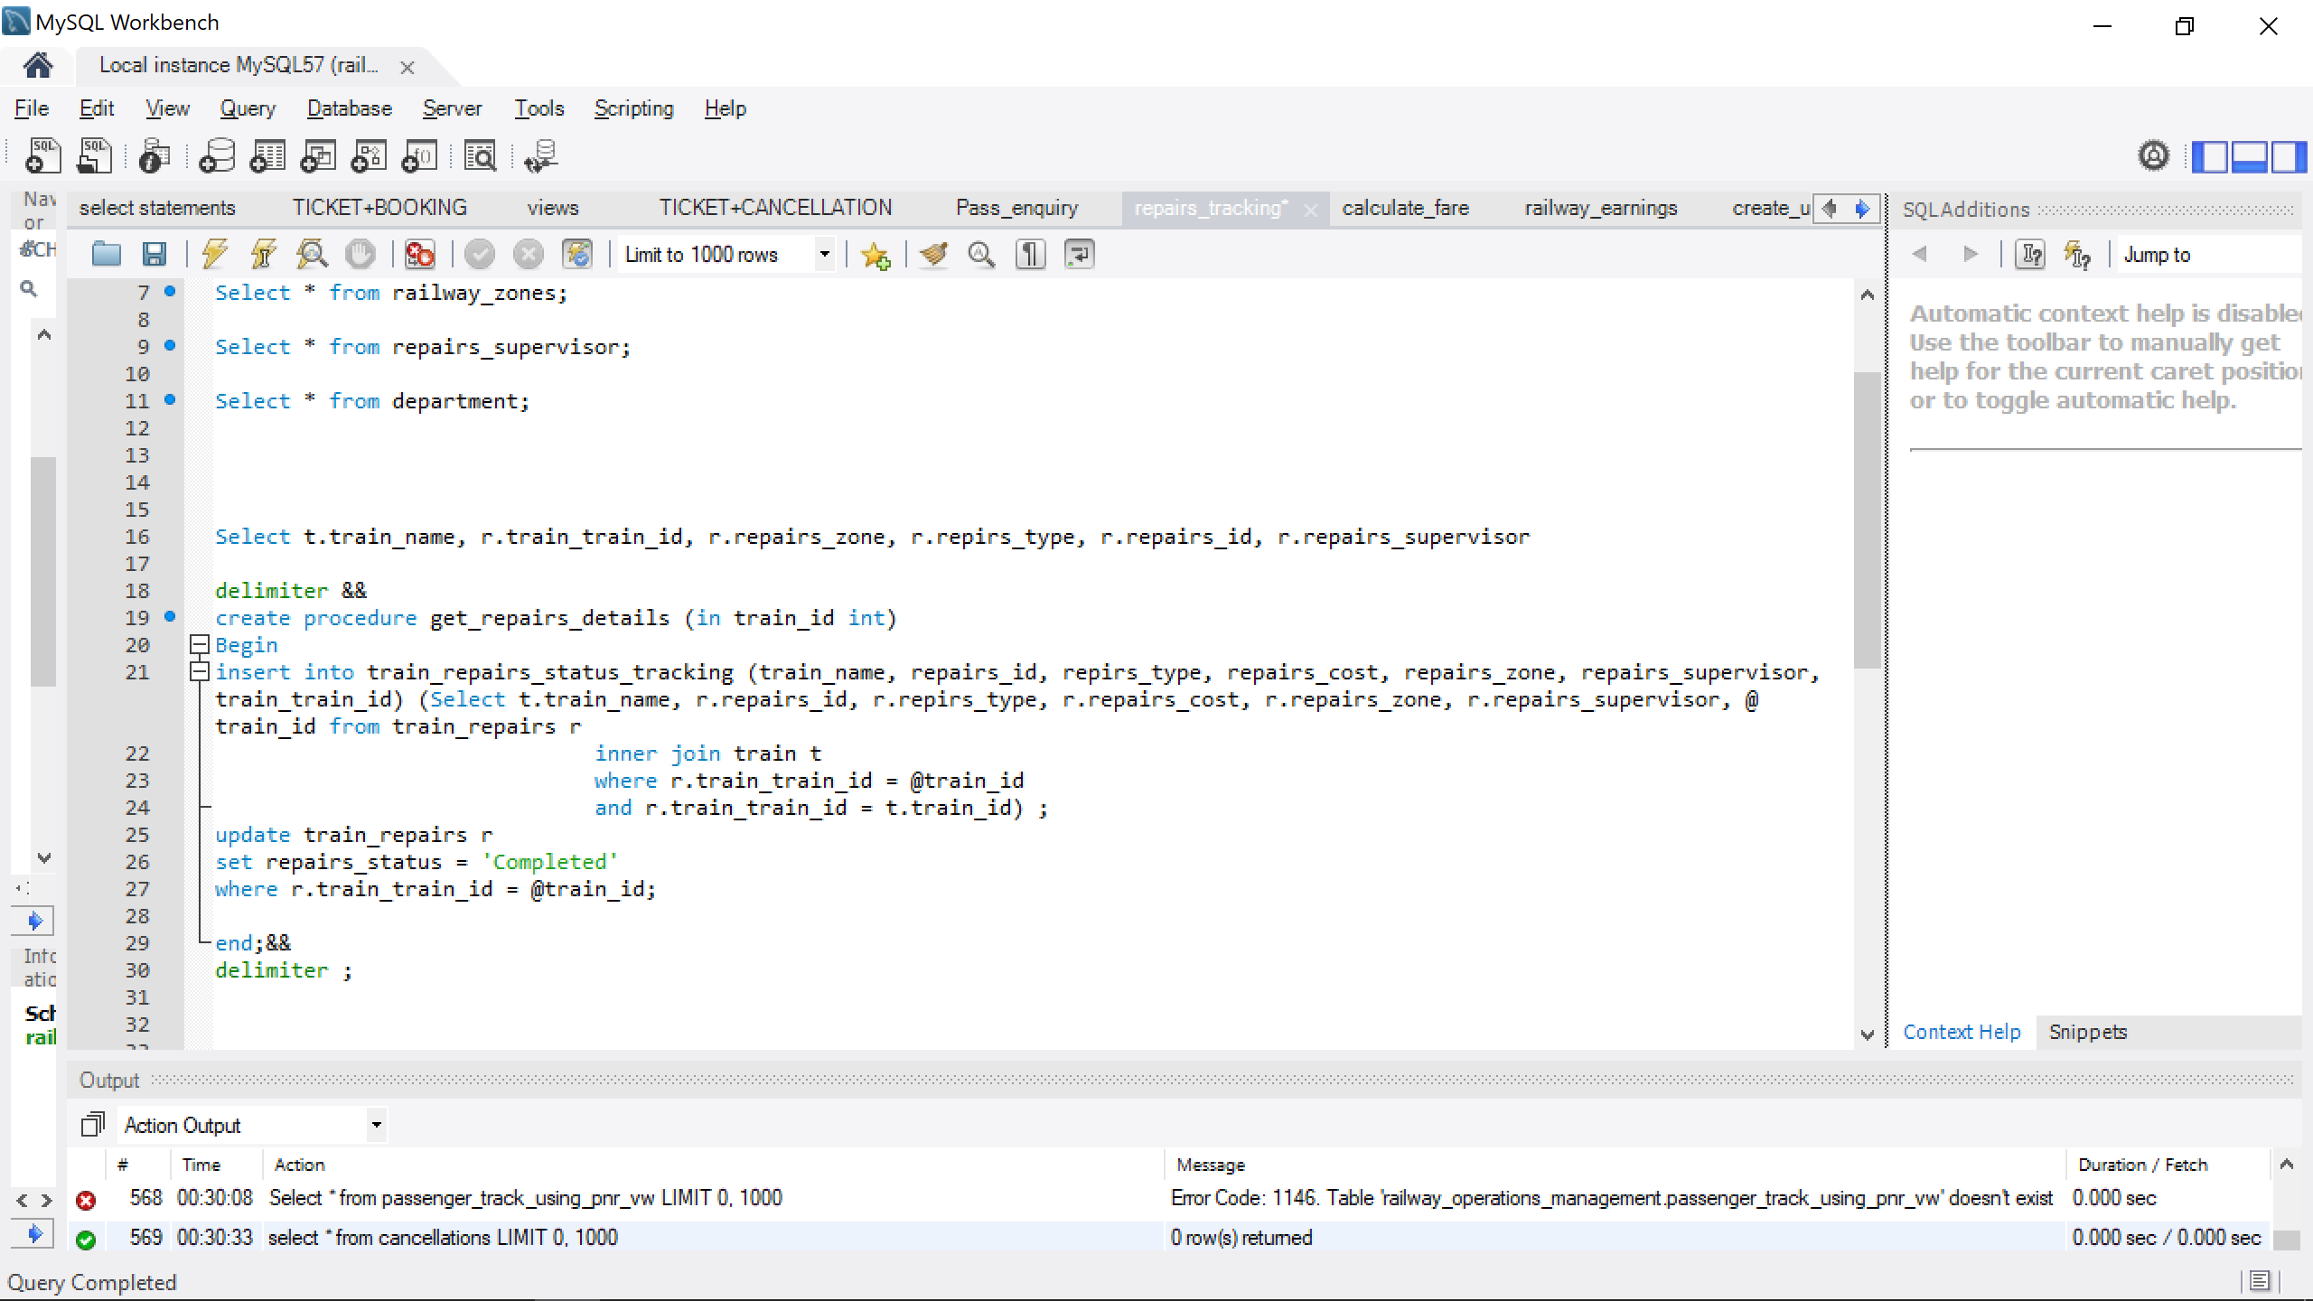

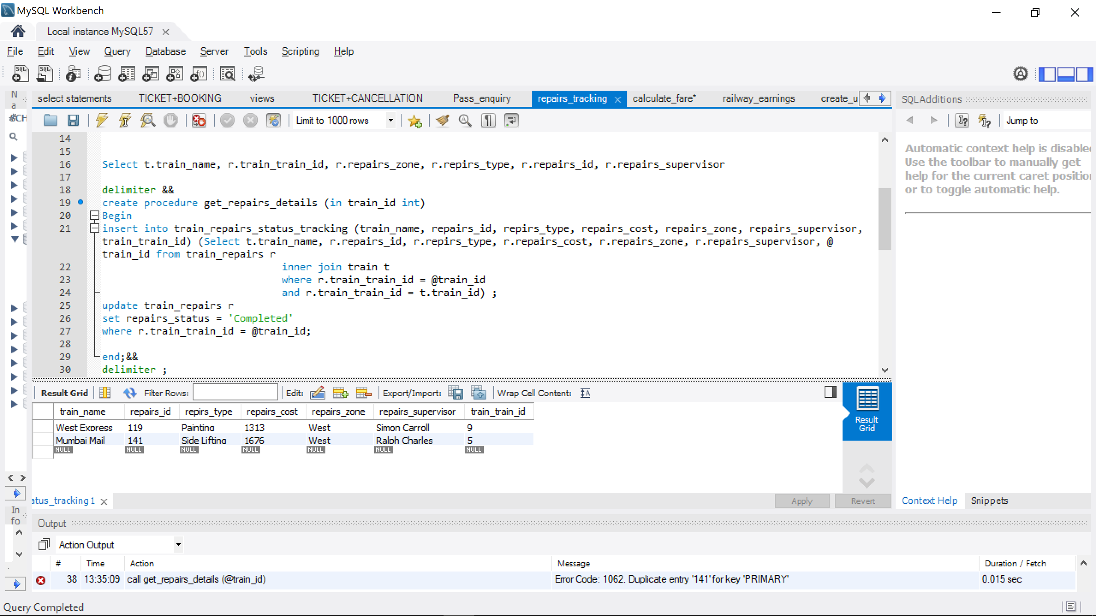

5.) Calculate Fare

The following procedure calculates the fare for the queried train and class type.

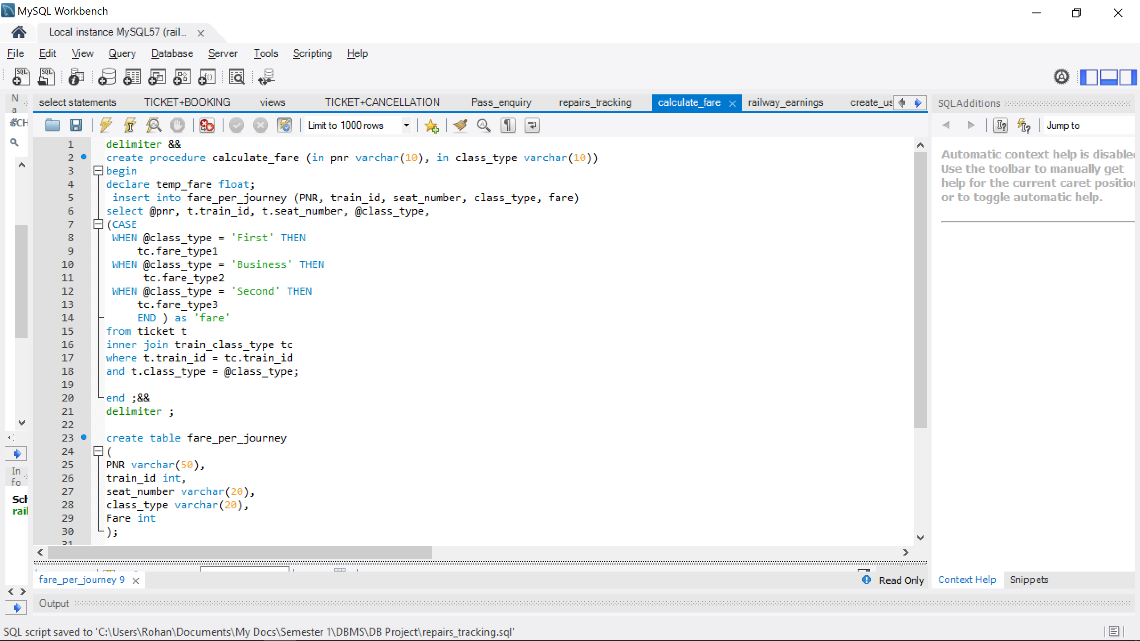

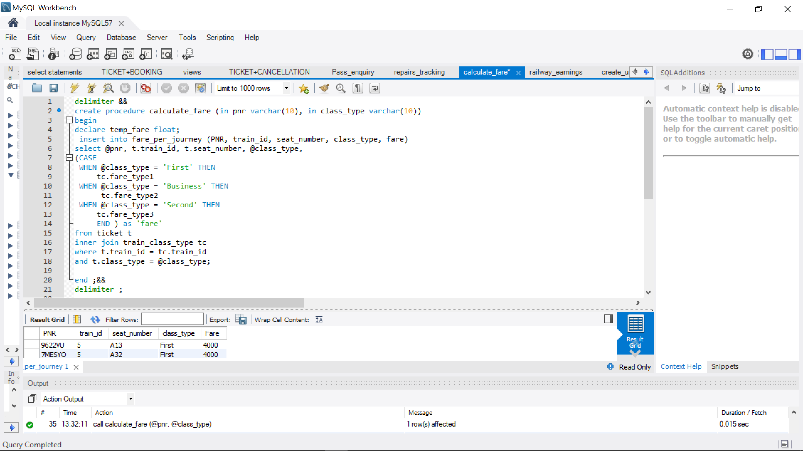

6.) Railway Earnings

The following view gives a comparison between total earnings and the expenses of a particular zone

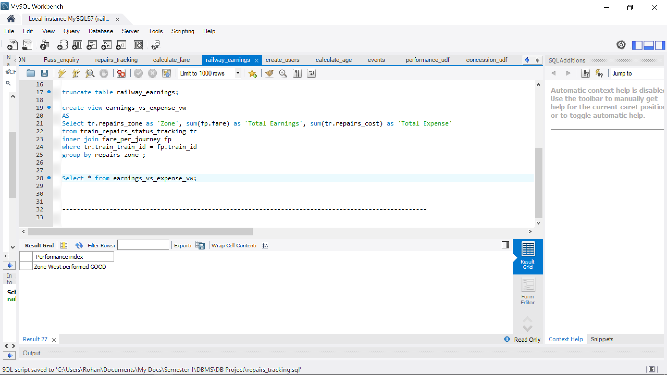

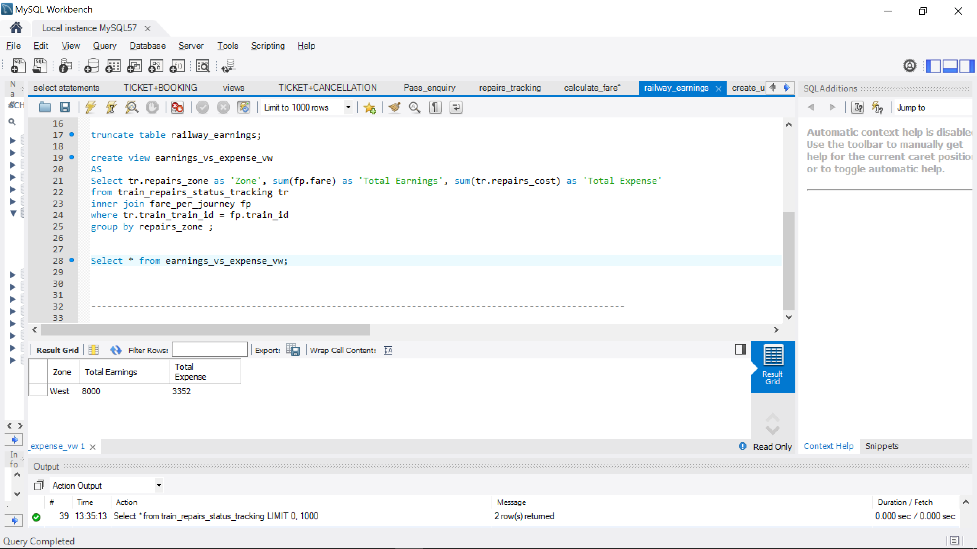

7.) Users and Privileges

This section grants users various permission levels in order to ensure data security.

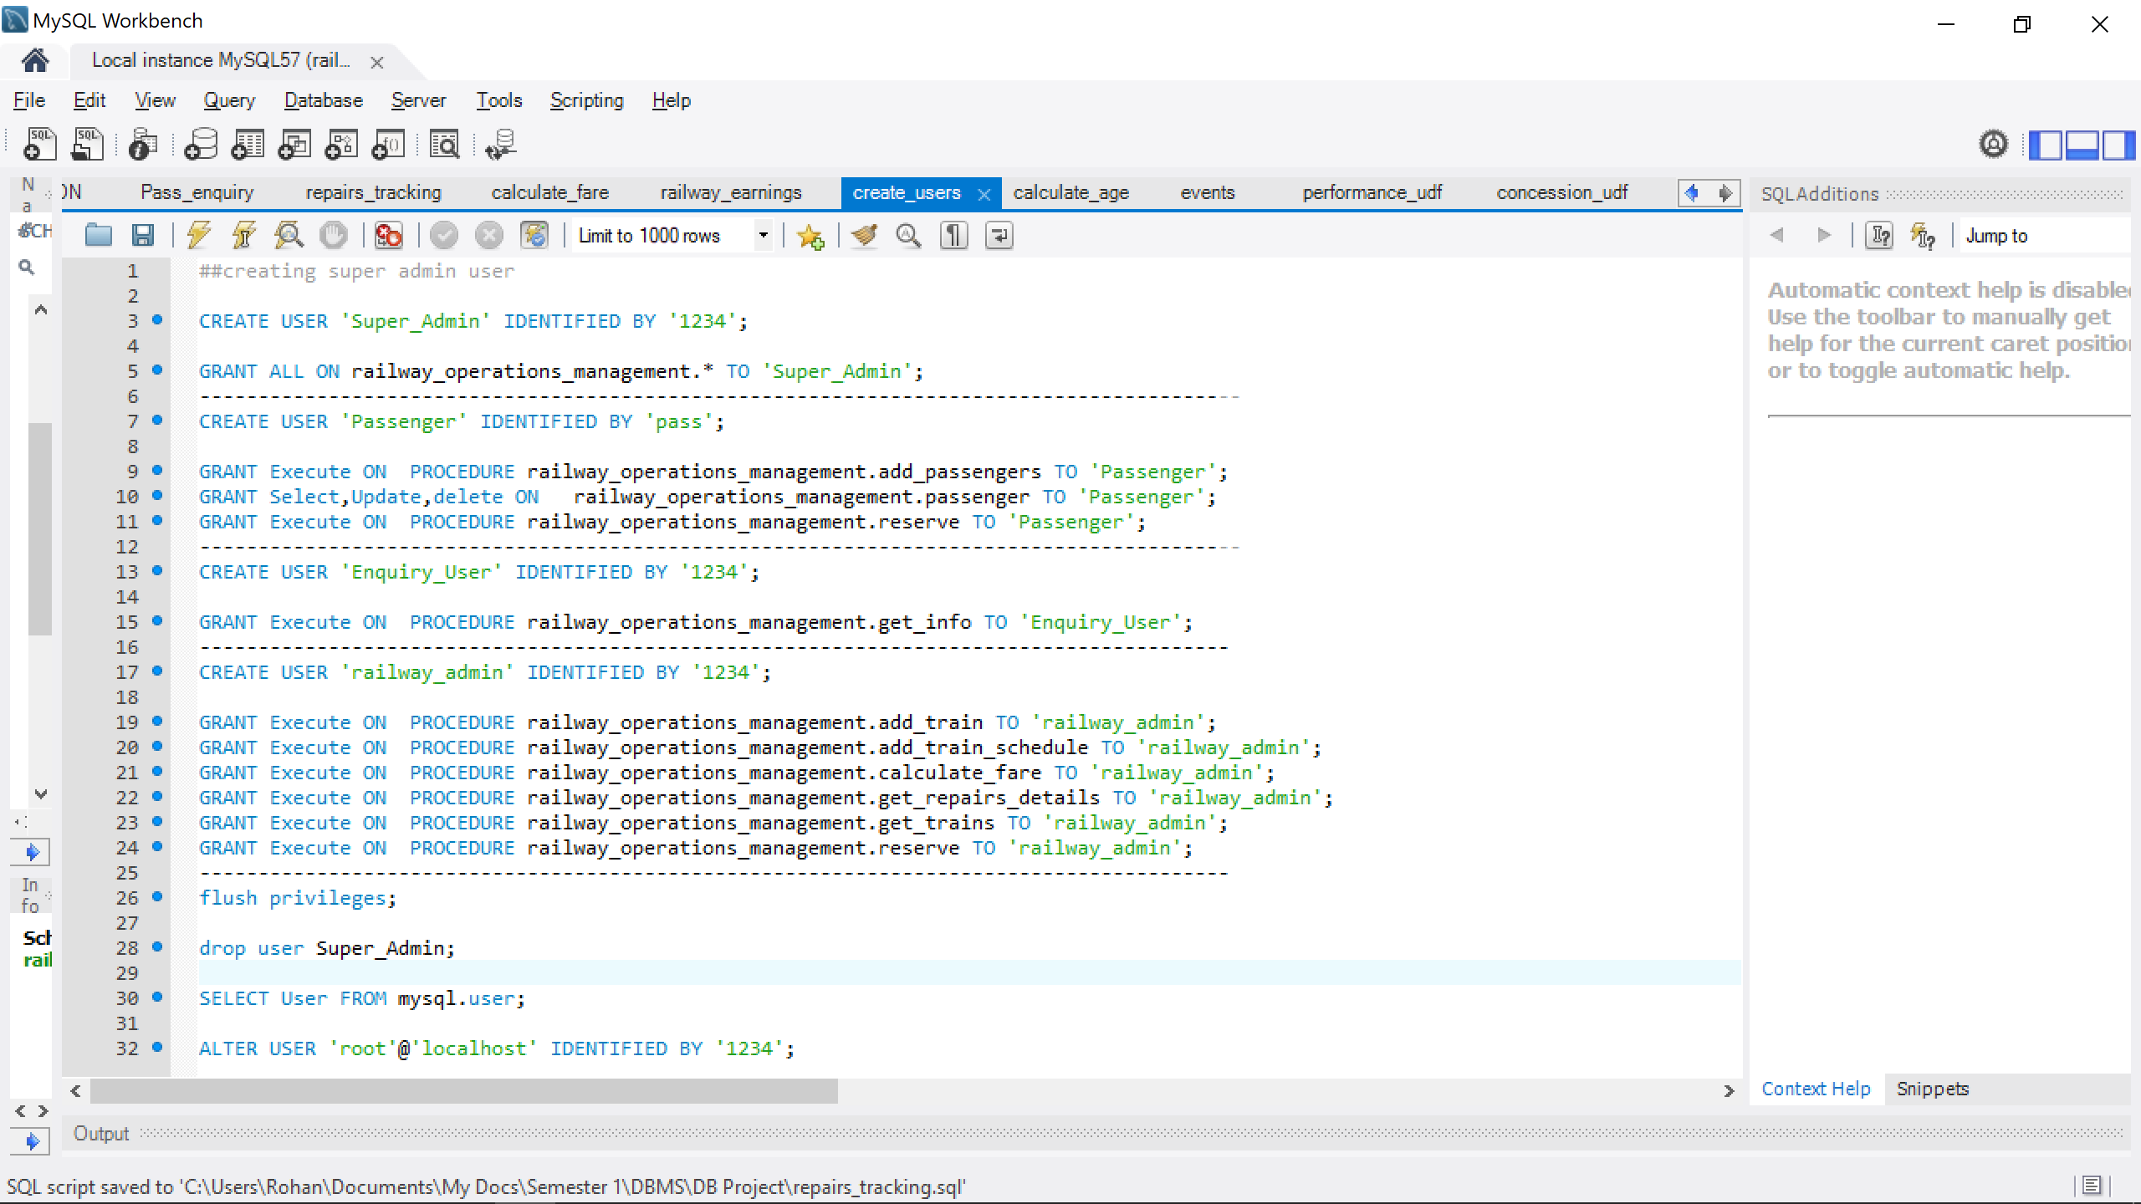

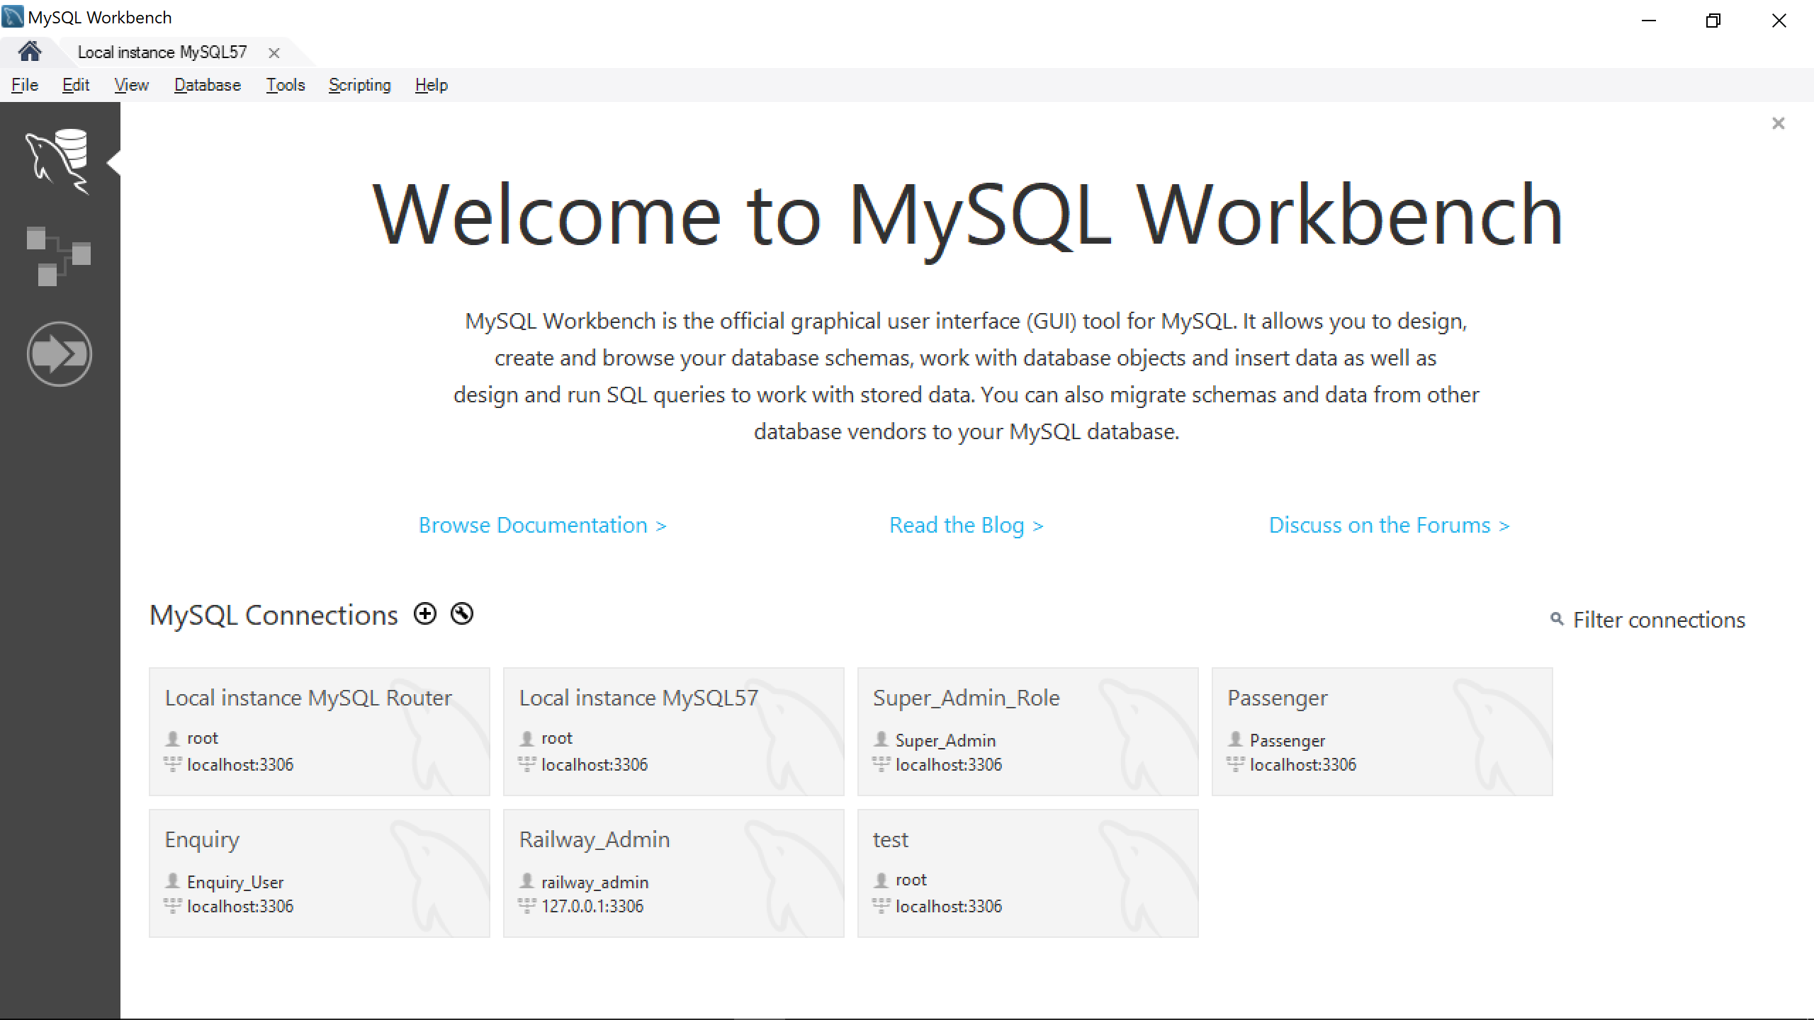

8.) Calculate passenger age

This view provides the age-group of the passenger who has booked the ticket.

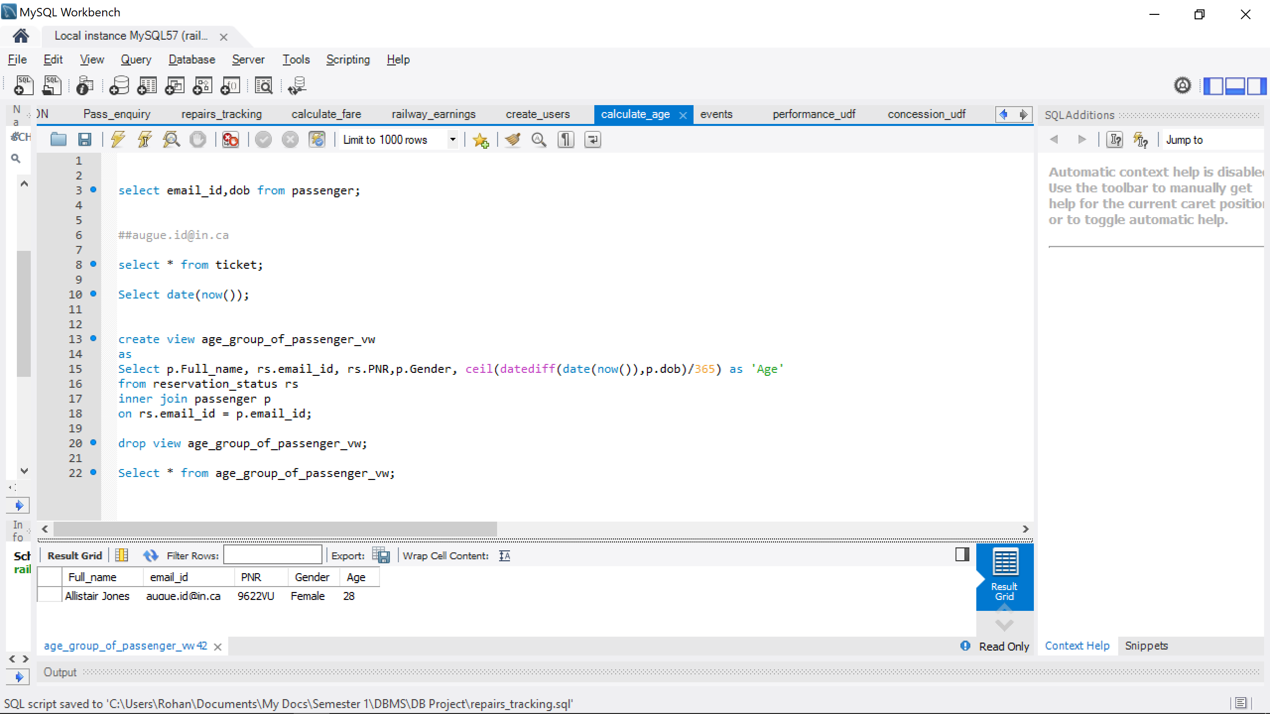

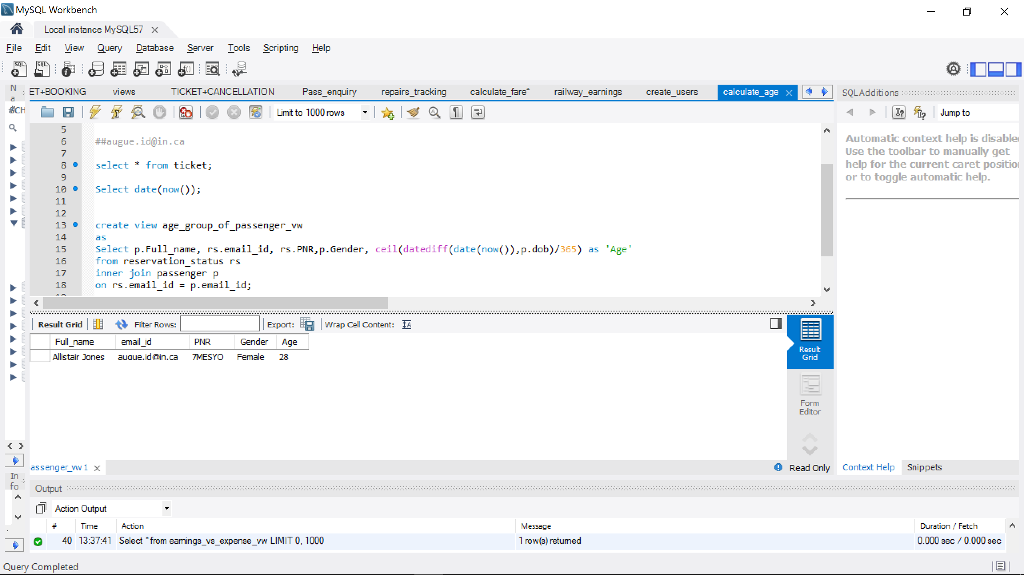

9.) Log events

Logs the number of tickets booked.

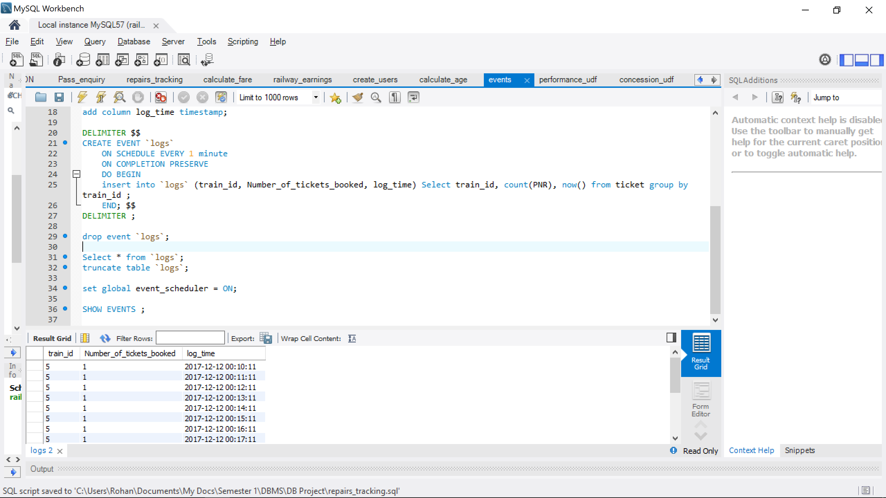

10.) Performance UDF

The user defined function grades the zone based on the comparison between its earnings from ticket sales and expenses from repairs.

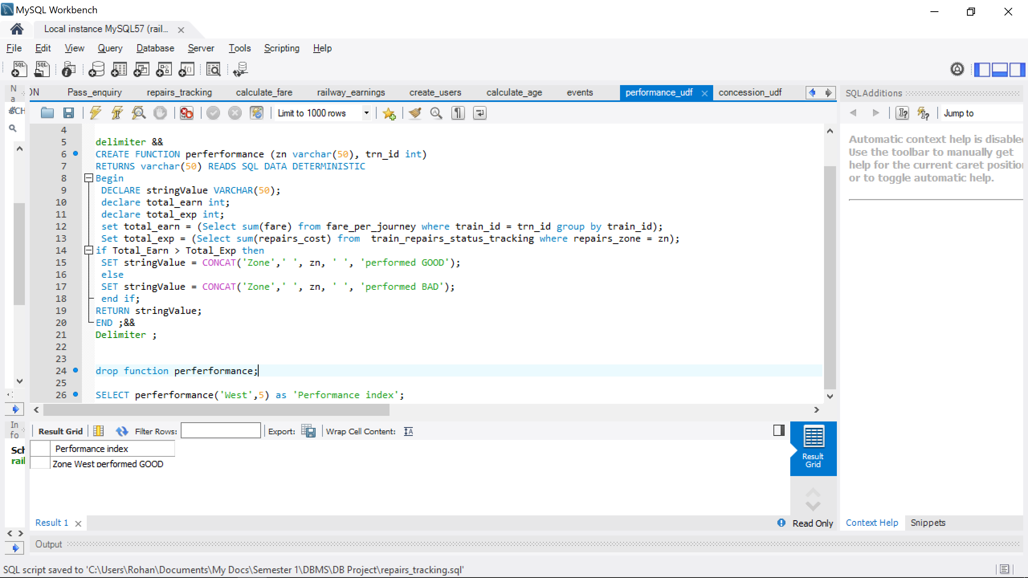

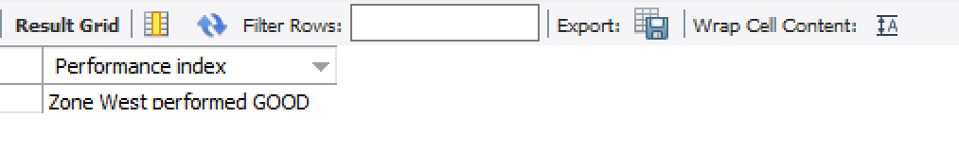

11.) Concession UDF

This user defined function provides information if the user is eligible for a travelers concession or not based on his age.

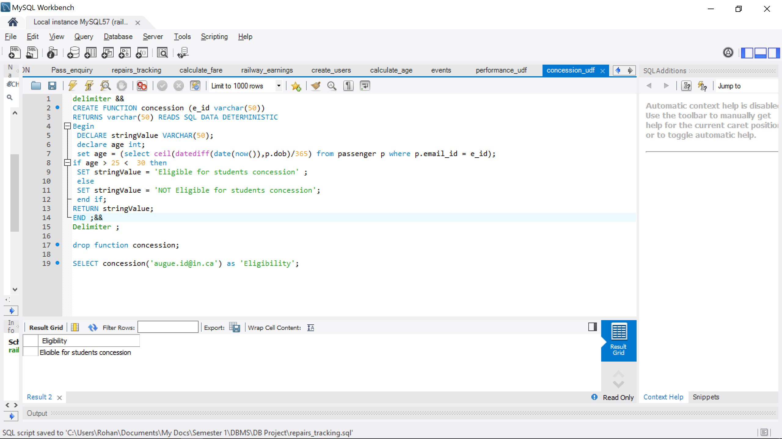

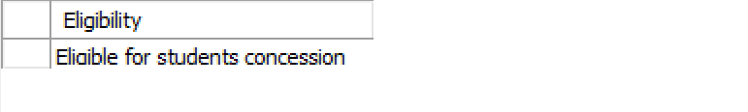

12.) Passenger Trigger

This trigger validates the data before it is stored in the database and throws an error if incorrectly entered.

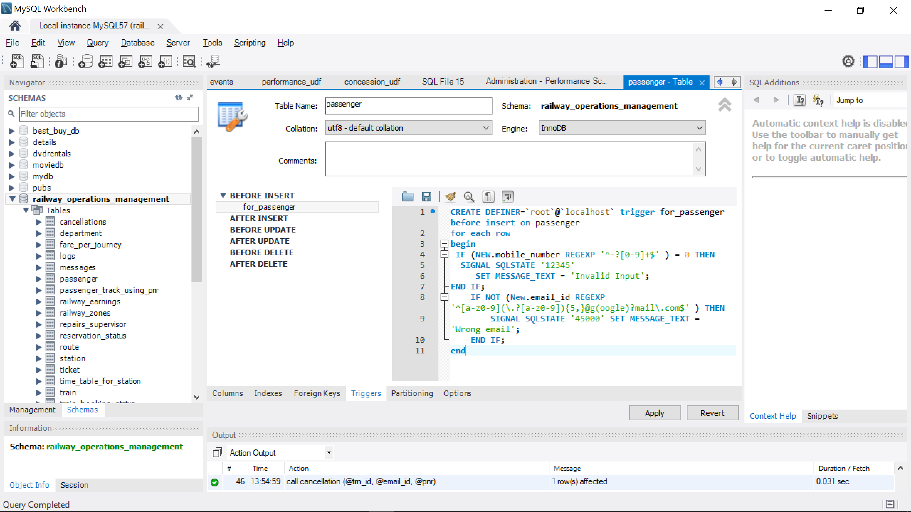

13.) Train Trigger

This trigger executes each time a new train is added to the system to validate if the train_id is not null.

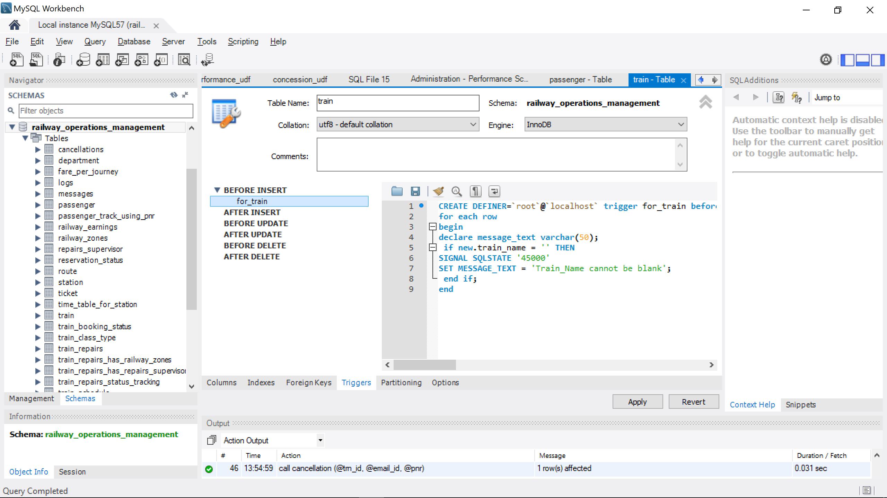

14.) Repairs Supervisor Trigger

Validates the data before it is inserted into the table.

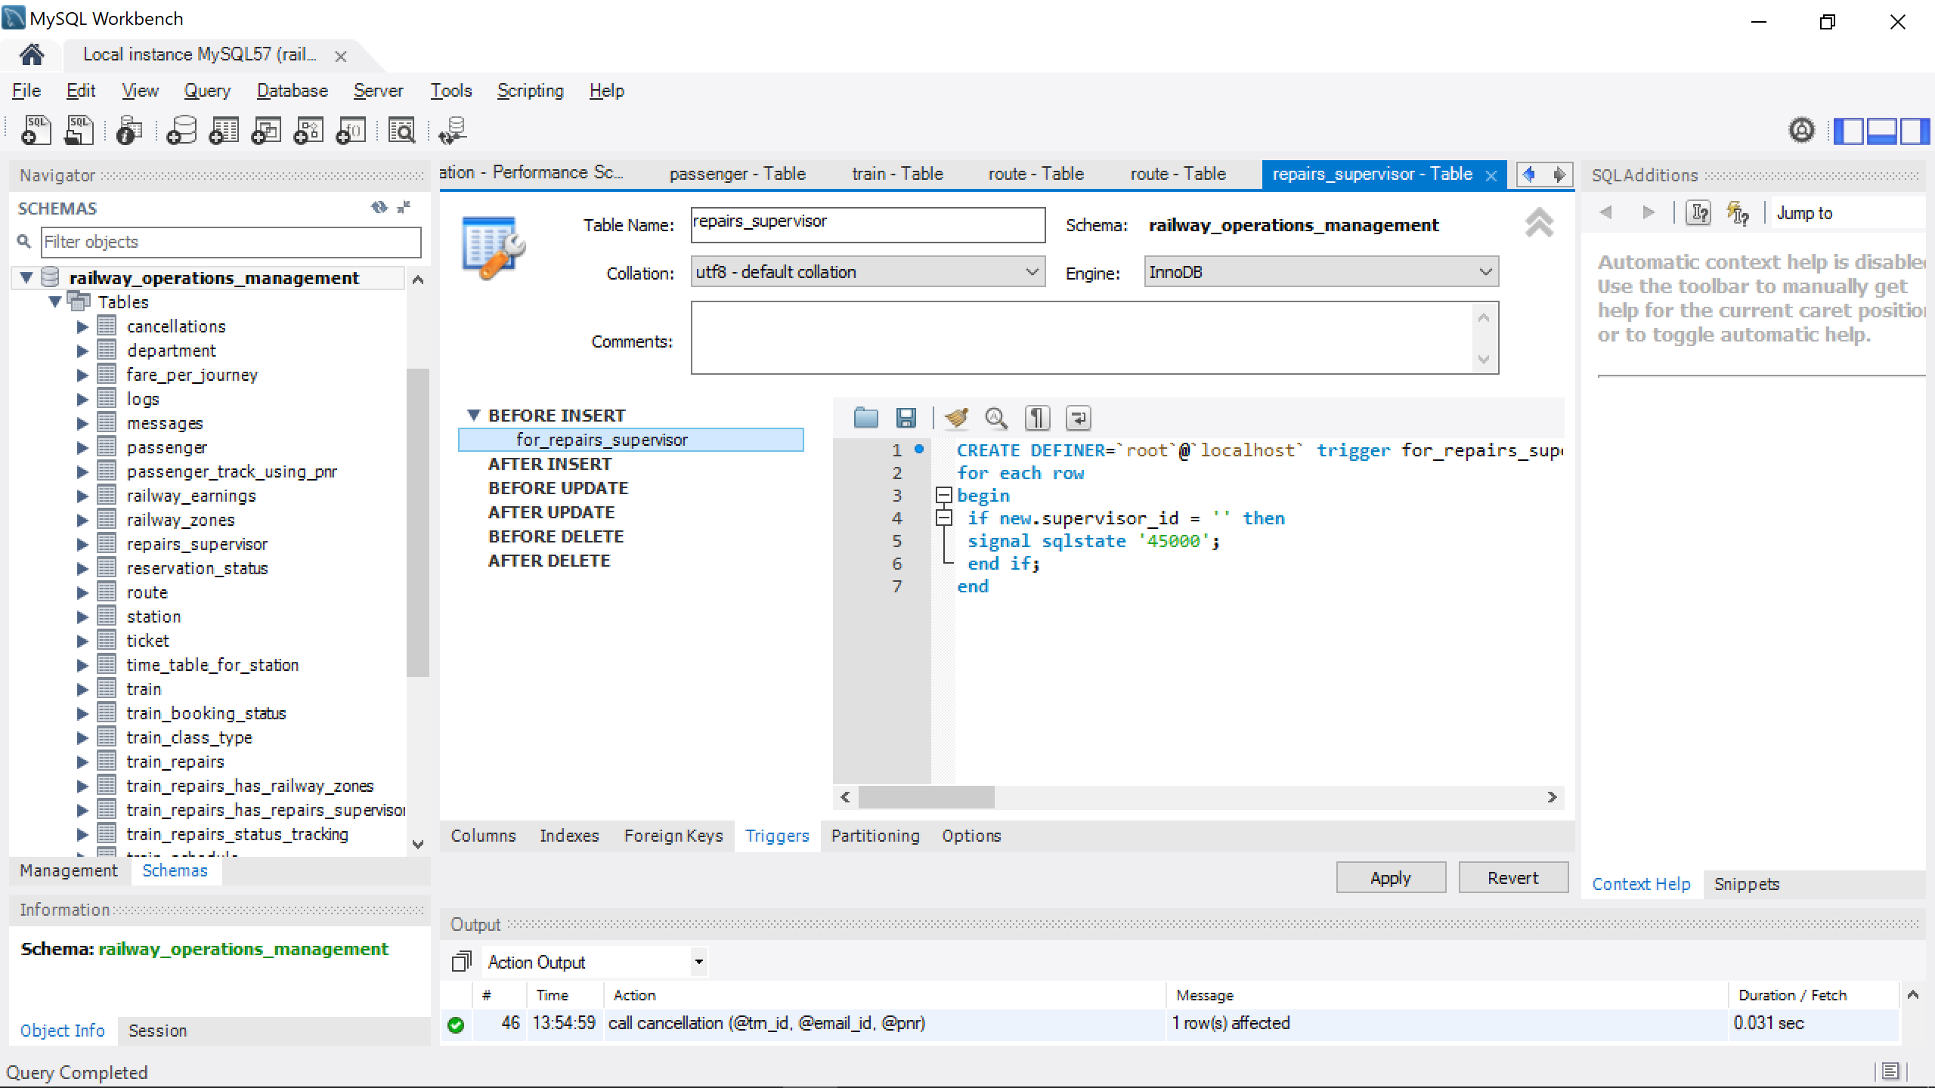

***Appendix:***

-- MySQL dump 10.13 Distrib 5.7.19, for Win64 (x86_64)

--

-- Host: localhost Database: railway_operations_management

-- ------------------------------------------------------

-- Server version 5.7.19-log

/*!40101 SET @OLD_CHARACTER_SET_CLIENT=@@CHARACTER_SET_CLIENT */;

/*!40101 SET @OLD_CHARACTER_SET_RESULTS=@@CHARACTER_SET_RESULTS */;

/*!40101 SET @OLD_COLLATION_CONNECTION=@@COLLATION_CONNECTION */;

/*!40101 SET NAMES utf8 */;

/*!40103 SET @OLD_TIME_ZONE=@@TIME_ZONE */;

/*!40103 SET TIME_ZONE='+00:00' */;

/*!40014 SET @OLD_UNIQUE_CHECKS=@@UNIQUE_CHECKS, UNIQUE_CHECKS=0 */;

/*!40014 SET @OLD_FOREIGN_KEY_CHECKS=@@FOREIGN_KEY_CHECKS, FOREIGN_KEY_CHECKS=0 */;

/*!40101 SET @OLD_SQL_MODE=@@SQL_MODE, SQL_MODE='NO_AUTO_VALUE_ON_ZERO' */;

/*!40111 SET @OLD_SQL_NOTES=@@SQL_NOTES, SQL_NOTES=0 */;

--

-- Temporary table structure for view `age_group_of_passenger_vw`

--

DROP TABLE IF EXISTS `age_group_of_passenger_vw`;

/*!50001 DROP VIEW IF EXISTS `age_group_of_passenger_vw`*/;

SET @saved_cs_client = @@character_set_client;

SET character_set_client = utf8;

/*!50001 CREATE VIEW `age_group_of_passenger_vw` AS SELECT

1 AS `Full_name`,

1 AS `email_id`,

1 AS `PNR`,

1 AS `Gender`,

1 AS `Age`*/;

SET character_set_client = @saved_cs_client;

--

-- Table structure for table `cancellations`

--

DROP TABLE IF EXISTS `cancellations`;

/*!40101 SET @saved_cs_client = @@character_set_client */;

/*!40101 SET character_set_client = utf8 */;

CREATE TABLE `cancellations` (

`train_id` int(11) NOT NULL,

`email_id` varchar(30) NOT NULL,

`PNR` varchar(20) NOT NULL,

`date_cancelled` date NOT NULL,

`status` varchar(10) DEFAULT NULL,

PRIMARY KEY (`train_id`,`email_id`,`PNR`),

KEY `rstatus_ibfk_1` (`email_id`),

CONSTRAINT `rstatus_ibfk_1` FOREIGN KEY (`email_id`) REFERENCES `passenger` (`email_id`) ON DELETE CASCADE ON UPDATE CASCADE

) ENGINE=InnoDB DEFAULT CHARSET=utf8;

/*!40101 SET character_set_client = @saved_cs_client */;

--

-- Dumping data for table `cancellations`

--

LOCK TABLES `cancellations` WRITE;

/*!40000 ALTER TABLE `cancellations` DISABLE KEYS */;

INSERT INTO `cancellations` VALUES (5,'augue.id@in.ca','7MESYO','2017-12-12','Cancelled');

/*!40000 ALTER TABLE `cancellations` ENABLE KEYS */;

UNLOCK TABLES;

--

-- Table structure for table `department`

--

DROP TABLE IF EXISTS `department`;

/*!40101 SET @saved_cs_client = @@character_set_client */;

/*!40101 SET character_set_client = utf8 */;

CREATE TABLE `department` (

`department_id` int(11) NOT NULL,

`department_name` varchar(45) NOT NULL,

PRIMARY KEY (`department_id`)

) ENGINE=InnoDB DEFAULT CHARSET=utf8;

/*!40101 SET character_set_client = @saved_cs_client */;

--

-- Dumping data for table `department`

--

LOCK TABLES `department` WRITE;

/*!40000 ALTER TABLE `department` DISABLE KEYS */;

INSERT INTO `department` VALUES (1,'Manufacturing'),(2,'Maintenance'),(3,'Field Services'),(4,'Repairs');

/*!40000 ALTER TABLE `department` ENABLE KEYS */;

UNLOCK TABLES;

/*!50003 SET @saved_cs_client = @@character_set_client */ ;

/*!50003 SET @saved_cs_results = @@character_set_results */ ;

/*!50003 SET @saved_col_connection = @@collation_connection */ ;

/*!50003 SET character_set_client = utf8 */ ;

/*!50003 SET character_set_results = utf8 */ ;

/*!50003 SET collation_connection = utf8_general_ci */ ;

/*!50003 SET @saved_sql_mode = @@sql_mode */ ;

/*!50003 SET sql_mode = 'STRICT_TRANS_TABLES,NO_AUTO_CREATE_USER,NO_ENGINE_SUBSTITUTION' */ ;

DELIMITER ;;

/*!50003 CREATE*/ /*!50017 DEFINER=`root`@`localhost`*/ /*!50003 trigger for_department before insert on department

for each row

begin

if new.department_id = '' then

signal sqlstate '45000';

elseif

new.department_name = '' then

signal sqlstate '45000';

end if;

end */;;

DELIMITER ;

/*!50003 SET sql_mode = @saved_sql_mode */ ;

/*!50003 SET character_set_client = @saved_cs_client */ ;

/*!50003 SET character_set_results = @saved_cs_results */ ;

/*!50003 SET collation_connection = @saved_col_connection */ ;

--

-- Temporary table structure for view `earnings_vs_expense_vw`

--

DROP TABLE IF EXISTS `earnings_vs_expense_vw`;

/*!50001 DROP VIEW IF EXISTS `earnings_vs_expense_vw`*/;

SET @saved_cs_client = @@character_set_client;

SET character_set_client = utf8;

/*!50001 CREATE VIEW `earnings_vs_expense_vw` AS SELECT

1 AS `Zone`,

1 AS `Total Earnings`,

1 AS `Total Expense`*/;

SET character_set_client = @saved_cs_client;

--

-- Table structure for table `fare_per_journey`

--

DROP TABLE IF EXISTS `fare_per_journey`;

/*!40101 SET @saved_cs_client = @@character_set_client */;

/*!40101 SET character_set_client = utf8 */;

CREATE TABLE `fare_per_journey` (

`PNR` varchar(50) DEFAULT NULL,

`train_id` int(11) DEFAULT NULL,

`seat_number` varchar(20) DEFAULT NULL,

`class_type` varchar(20) DEFAULT NULL,

`Fare` int(11) DEFAULT NULL

) ENGINE=InnoDB DEFAULT CHARSET=utf8;

/*!40101 SET character_set_client = @saved_cs_client */;

--

-- Dumping data for table `fare_per_journey`

--

LOCK TABLES `fare_per_journey` WRITE;

/*!40000 ALTER TABLE `fare_per_journey` DISABLE KEYS */;

INSERT INTO `fare_per_journey` VALUES ('9622VU',5,'A13','First',4000),('7MESYO',5,'A32','First',4000);

/*!40000 ALTER TABLE `fare_per_journey` ENABLE KEYS */;

UNLOCK TABLES;

--

-- Table structure for table `logs`

--

DROP TABLE IF EXISTS `logs`;

/*!40101 SET @saved_cs_client = @@character_set_client */;

/*!40101 SET character_set_client = utf8 */;

CREATE TABLE `logs` (

`train_id` int(11) DEFAULT NULL,

`Number_of_tickets_booked` int(11) DEFAULT NULL,

`log_time` timestamp NOT NULL DEFAULT CURRENT_TIMESTAMP ON UPDATE CURRENT_TIMESTAMP

) ENGINE=InnoDB DEFAULT CHARSET=utf8;

/*!40101 SET character_set_client = @saved_cs_client */;

--

-- Dumping data for table `logs`

--

LOCK TABLES `logs` WRITE;

/*!40000 ALTER TABLE `logs` DISABLE KEYS */;

INSERT INTO `logs` VALUES (5,1,'2017-12-12 05:10:11'),(5,1,'2017-12-12 05:11:11'),(5,1,'2017-12-12 05:12:11'),(5,1,'2017-12-12 05:13:11'),(5,1,'2017-12-12 05:14:11'),(5,1,'2017-12-12 05:15:11'),(5,1,'2017-12-12 05:16:11'),(5,1,'2017-12-12 05:17:11'),(5,1,'2017-12-12 05:18:11'),(5,1,'2017-12-12 05:19:11'),(5,1,'2017-12-12 05:20:11'),(5,1,'2017-12-12 05:21:11'),(5,1,'2017-12-12 05:22:11'),(3,1,'2017-12-12 05:23:11'),(5,1,'2017-12-12 05:23:11'),(3,1,'2017-12-12 05:24:11'),(5,1,'2017-12-12 05:24:11'),(3,1,'2017-12-12 05:25:11'),(5,1,'2017-12-12 05:25:11'),(3,1,'2017-12-12 05:26:11'),(5,1,'2017-12-12 05:26:11'),(3,1,'2017-12-12 05:27:11'),(5,1,'2017-12-12 05:27:11'),(3,1,'2017-12-12 05:28:11'),(5,1,'2017-12-12 05:28:11'),(3,1,'2017-12-12 05:29:11'),(5,1,'2017-12-12 05:29:11'),(3,1,'2017-12-12 05:30:11'),(5,1,'2017-12-12 05:30:11'),(3,1,'2017-12-12 05:31:11'),(5,1,'2017-12-12 05:31:11'),(3,1,'2017-12-12 05:32:11'),(5,1,'2017-12-12 05:32:11'),(3,1,'2017-12-12 05:33:11'),(5,1,'2017-12-12 05:33:11'),(3,1,'2017-12-12 05:34:11'),(5,1,'2017-12-12 05:34:11'),(3,1,'2017-12-12 05:35:11'),(5,1,'2017-12-12 05:35:11'),(3,1,'2017-12-12 05:36:11'),(5,1,'2017-12-12 05:36:11'),(3,1,'2017-12-12 05:37:11'),(5,1,'2017-12-12 05:37:11'),(3,1,'2017-12-12 05:38:11'),(5,1,'2017-12-12 05:38:11'),(3,1,'2017-12-12 05:39:11'),(5,1,'2017-12-12 05:39:11'),(3,1,'2017-12-12 05:40:11'),(5,1,'2017-12-12 05:40:11'),(3,1,'2017-12-12 05:41:11'),(5,1,'2017-12-12 05:41:11'),(3,1,'2017-12-12 05:42:11'),(5,1,'2017-12-12 05:42:11'),(3,1,'2017-12-12 05:43:11'),(5,1,'2017-12-12 05:43:11'),(3,1,'2017-12-12 05:44:11'),(5,1,'2017-12-12 05:44:11'),(3,1,'2017-12-12 05:45:11'),(5,1,'2017-12-12 05:45:11'),(3,1,'2017-12-12 05:46:11'),(5,1,'2017-12-12 05:46:11'),(3,1,'2017-12-12 05:47:11'),(5,1,'2017-12-12 05:47:11'),(3,1,'2017-12-12 05:48:11'),(5,1,'2017-12-12 05:48:11'),(3,1,'2017-12-12 05:49:11'),(5,1,'2017-12-12 05:49:11'),(3,1,'2017-12-12 05:50:11'),(5,1,'2017-12-12 05:50:11'),(3,1,'2017-12-12 05:51:11'),(5,1,'2017-12-12 05:51:11'),(3,1,'2017-12-12 05:52:11'),(5,1,'2017-12-12 05:52:11'),(3,1,'2017-12-12 05:53:11'),(5,1,'2017-12-12 05:53:11'),(3,1,'2017-12-12 05:54:11'),(5,1,'2017-12-12 05:54:11'),(3,1,'2017-12-12 05:55:11'),(5,1,'2017-12-12 05:55:11'),(3,1,'2017-12-12 05:56:11'),(5,1,'2017-12-12 05:56:11'),(3,1,'2017-12-12 05:57:11'),(5,1,'2017-12-12 05:57:11'),(3,1,'2017-12-12 05:58:11'),(5,1,'2017-12-12 05:58:11'),(3,1,'2017-12-12 07:27:20'),(5,1,'2017-12-12 07:27:20'),(3,1,'2017-12-12 07:28:11'),(5,1,'2017-12-12 07:28:11'),(3,1,'2017-12-12 07:29:11'),(5,1,'2017-12-12 07:29:11'),(3,1,'2017-12-12 07:30:11'),(5,1,'2017-12-12 07:30:11'),(3,1,'2017-12-12 07:31:11'),(5,1,'2017-12-12 07:31:11'),(3,1,'2017-12-12 07:32:11'),(5,1,'2017-12-12 07:32:11'),(3,1,'2017-12-12 07:33:11'),(5,1,'2017-12-12 07:33:11'),(3,1,'2017-12-12 07:34:11'),(5,1,'2017-12-12 07:34:11'),(3,1,'2017-12-12 07:35:11'),(5,1,'2017-12-12 07:35:11'),(3,1,'2017-12-12 07:36:11'),(5,1,'2017-12-12 07:36:11'),(3,1,'2017-12-12 07:37:11'),(5,1,'2017-12-12 07:37:11'),(3,1,'2017-12-12 07:38:11'),(5,1,'2017-12-12 07:38:11'),(3,1,'2017-12-12 07:39:11'),(5,1,'2017-12-12 07:39:11'),(3,1,'2017-12-12 07:40:11'),(5,1,'2017-12-12 07:40:11'),(3,1,'2017-12-12 07:41:11'),(5,1,'2017-12-12 07:41:11'),(3,1,'2017-12-12 07:42:11'),(5,1,'2017-12-12 07:42:11'),(3,1,'2017-12-12 07:43:11'),(5,1,'2017-12-12 07:43:11'),(3,1,'2017-12-12 07:44:11'),(5,1,'2017-12-12 07:44:11'),(3,1,'2017-12-12 07:45:11'),(5,1,'2017-12-12 07:45:11'),(3,1,'2017-12-12 07:46:11'),(5,1,'2017-12-12 07:46:11'),(3,1,'2017-12-12 07:47:11'),(5,1,'2017-12-12 07:47:11'),(3,1,'2017-12-12 07:48:11'),(5,1,'2017-12-12 07:48:11'),(3,1,'2017-12-12 07:49:11'),(5,1,'2017-12-12 07:49:11'),(3,1,'2017-12-12 07:50:11'),(5,1,'2017-12-12 07:50:11'),(3,1,'2017-12-12 07:51:11'),(5,1,'2017-12-12 07:51:11'),(3,1,'2017-12-12 07:52:11'),(5,1,'2017-12-12 07:52:11'),(3,1,'2017-12-12 07:53:11'),(5,1,'2017-12-12 07:53:11'),(3,1,'2017-12-12 07:54:11'),(5,1,'2017-12-12 07:54:11'),(3,1,'2017-12-12 07:55:11'),(5,1,'2017-12-12 07:55:11'),(3,1,'2017-12-12 07:56:11'),(5,1,'2017-12-12 07:56:11'),(3,1,'2017-12-12 07:57:11'),(5,1,'2017-12-12 07:57:11'),(3,1,'2017-12-12 07:58:11'),(5,1,'2017-12-12 07:58:11'),(3,1,'2017-12-12 07:59:11'),(5,1,'2017-12-12 07:59:11'),(3,1,'2017-12-12 08:00:11'),(5,1,'2017-12-12 08:00:11'),(3,1,'2017-12-12 08:01:11'),(5,1,'2017-12-12 08:01:11'),(3,1,'2017-12-12 08:02:11'),(5,1,'2017-12-12 08:02:11'),(3,1,'2017-12-12 08:03:11'),(5,1,'2017-12-12 08:03:11'),(3,1,'2017-12-12 08:04:11'),(5,1,'2017-12-12 08:04:11'),(3,1,'2017-12-12 08:05:11'),(5,1,'2017-12-12 08:05:11'),(3,1,'2017-12-12 08:06:11'),(5,1,'2017-12-12 08:06:11'),(3,1,'2017-12-12 08:07:11'),(5,1,'2017-12-12 08:07:11'),(3,1,'2017-12-12 08:08:11'),(5,1,'2017-12-12 08:08:11'),(3,1,'2017-12-12 08:09:11'),(5,1,'2017-12-12 08:09:11'),(3,1,'2017-12-12 08:10:11'),(5,1,'2017-12-12 08:10:11'),(3,1,'2017-12-12 08:11:11'),(5,1,'2017-12-12 08:11:11'),(3,1,'2017-12-12 08:12:11'),(5,1,'2017-12-12 08:12:11'),(3,1,'2017-12-12 08:13:11'),(5,1,'2017-12-12 08:13:11'),(3,1,'2017-12-12 08:14:11'),(5,1,'2017-12-12 08:14:11'),(3,1,'2017-12-12 08:15:11'),(5,1,'2017-12-12 08:15:11'),(3,1,'2017-12-12 08:16:11'),(5,1,'2017-12-12 08:16:11'),(3,1,'2017-12-12 08:17:11'),(5,1,'2017-12-12 08:17:11'),(3,1,'2017-12-12 08:18:11'),(5,1,'2017-12-12 08:18:11'),(3,1,'2017-12-12 08:19:11'),(5,1,'2017-12-12 08:19:11'),(3,1,'2017-12-12 08:20:11'),(5,1,'2017-12-12 08:20:11'),(3,1,'2017-12-12 08:21:11'),(5,1,'2017-12-12 08:21:11'),(3,1,'2017-12-12 08:22:11'),(5,1,'2017-12-12 08:22:11'),(3,1,'2017-12-12 08:23:11'),(5,1,'2017-12-12 08:23:11'),(3,1,'2017-12-12 08:24:11'),(5,1,'2017-12-12 08:24:11'),(3,1,'2017-12-12 08:25:11'),(5,1,'2017-12-12 08:25:11'),(3,1,'2017-12-12 08:26:11'),(5,1,'2017-12-12 08:26:11'),(3,1,'2017-12-12 08:27:11'),(5,1,'2017-12-12 08:27:11'),(3,1,'2017-12-12 08:28:11'),(5,1,'2017-12-12 08:28:11'),(3,1,'2017-12-12 08:29:11'),(5,1,'2017-12-12 08:29:11'),(3,1,'2017-12-12 08:30:11'),(5,1,'2017-12-12 08:30:11'),(3,1,'2017-12-12 08:31:11'),(5,1,'2017-12-12 08:31:11'),(3,1,'2017-12-12 08:32:11'),(5,1,'2017-12-12 08:32:11'),(3,1,'2017-12-12 08:33:11'),(5,1,'2017-12-12 08:33:11'),(3,1,'2017-12-12 08:34:11'),(5,1,'2017-12-12 08:34:11'),(3,1,'2017-12-12 08:35:11'),(5,1,'2017-12-12 08:35:11'),(3,1,'2017-12-12 08:36:11'),(5,1,'2017-12-12 08:36:11'),(3,1,'2017-12-12 08:37:11'),(5,1,'2017-12-12 08:37:11'),(3,1,'2017-12-12 08:38:11'),(5,1,'2017-12-12 08:38:11'),(3,1,'2017-12-12 08:39:11'),(5,1,'2017-12-12 08:39:11'),(3,1,'2017-12-12 08:40:11'),(5,1,'2017-12-12 08:40:11'),(3,1,'2017-12-12 08:41:11'),(5,1,'2017-12-12 08:41:11'),(3,1,'2017-12-12 08:42:11'),(5,1,'2017-12-12 08:42:11'),(3,1,'2017-12-12 08:43:11'),(5,1,'2017-12-12 08:43:11'),(3,1,'2017-12-12 08:44:11'),(5,1,'2017-12-12 08:44:11'),(3,1,'2017-12-12 08:45:11'),(5,1,'2017-12-12 08:45:11'),(3,1,'2017-12-12 08:46:11'),(5,1,'2017-12-12 08:46:11'),(3,1,'2017-12-12 08:47:11'),(5,1,'2017-12-12 08:47:11'),(3,1,'2017-12-12 08:48:11'),(5,1,'2017-12-12 08:48:11'),(3,1,'2017-12-12 08:49:11'),(5,1,'2017-12-12 08:49:11'),(3,1,'2017-12-12 08:50:11'),(5,1,'2017-12-12 08:50:11'),(3,1,'2017-12-12 08:51:11'),(5,1,'2017-12-12 08:51:11'),(3,1,'2017-12-12 08:52:11'),(5,1,'2017-12-12 08:52:11'),(3,1,'2017-12-12 08:53:11'),(5,1,'2017-12-12 08:53:11'),(3,1,'2017-12-12 08:54:11'),(5,1,'2017-12-12 08:54:11'),(3,1,'2017-12-12 08:55:11'),(5,1,'2017-12-12 08:55:11'),(3,1,'2017-12-12 08:56:11'),(5,1,'2017-12-12 08:56:11'),(3,1,'2017-12-12 08:57:11'),(5,1,'2017-12-12 08:57:11'),(3,1,'2017-12-12 08:58:11'),(5,1,'2017-12-12 08:58:11'),(3,1,'2017-12-12 08:59:12'),(5,1,'2017-12-12 08:59:12'),(3,1,'2017-12-12 09:00:11'),(5,1,'2017-12-12 09:00:11'),(3,1,'2017-12-12 09:01:11'),(5,1,'2017-12-12 09:01:11'),(3,1,'2017-12-12 09:02:11'),(5,1,'2017-12-12 09:02:11'),(3,1,'2017-12-12 09:03:11'),(5,1,'2017-12-12 09:03:11'),(3,1,'2017-12-12 09:04:11'),(5,1,'2017-12-12 09:04:11'),(3,1,'2017-12-12 09:05:11'),(5,1,'2017-12-12 09:05:11'),(3,1,'2017-12-12 09:06:11'),(5,1,'2017-12-12 09:06:11'),(3,1,'2017-12-12 09:07:11'),(5,1,'2017-12-12 09:07:11'),(3,1,'2017-12-12 09:08:11'),(5,1,'2017-12-12 09:08:11'),(3,1,'2017-12-12 09:09:11'),(5,1,'2017-12-12 09:09:11'),(3,1,'2017-12-12 09:10:11'),(5,1,'2017-12-12 09:10:11'),(3,1,'2017-12-12 09:11:11'),(5,1,'2017-12-12 09:11:11'),(3,1,'2017-12-12 09:12:11'),(5,1,'2017-12-12 09:12:11'),(3,1,'2017-12-12 09:13:11'),(5,1,'2017-12-12 09:13:11'),(3,1,'2017-12-12 09:14:11'),(5,1,'2017-12-12 09:14:11'),(3,1,'2017-12-12 09:15:11'),(5,1,'2017-12-12 09:15:11'),(3,1,'2017-12-12 09:16:11'),(5,1,'2017-12-12 09:16:11'),(3,1,'2017-12-12 09:17:11'),(5,1,'2017-12-12 09:17:11'),(3,1,'2017-12-12 09:18:11'),(5,1,'2017-12-12 09:18:11'),(3,1,'2017-12-12 09:19:11'),(5,1,'2017-12-12 09:19:11'),(3,1,'2017-12-12 09:20:11'),(5,1,'2017-12-12 09:20:11'),(3,1,'2017-12-12 09:21:11'),(5,1,'2017-12-12 09:21:11'),(3,1,'2017-12-12 09:22:11'),(5,1,'2017-12-12 09:22:11'),(3,1,'2017-12-12 09:23:11'),(5,1,'2017-12-12 09:23:11'),(3,1,'2017-12-12 09:24:11'),(5,1,'2017-12-12 09:24:11'),(3,1,'2017-12-12 09:25:11'),(5,1,'2017-12-12 09:25:11'),(3,1,'2017-12-12 09:26:11'),(5,1,'2017-12-12 09:26:11'),(3,1,'2017-12-12 09:27:11'),(5,1,'2017-12-12 09:27:11'),(3,1,'2017-12-12 09:28:11'),(5,1,'2017-12-12 09:28:11'),(3,1,'2017-12-12 09:29:11'),(5,1,'2017-12-12 09:29:11'),(3,1,'2017-12-12 09:30:11'),(5,1,'2017-12-12 09:30:11'),(3,1,'2017-12-12 09:31:11'),(5,1,'2017-12-12 09:31:11'),(3,1,'2017-12-12 09:32:11'),(5,1,'2017-12-12 09:32:11'),(3,1,'2017-12-12 09:33:11'),(5,1,'2017-12-12 09:33:11'),(3,1,'2017-12-12 09:34:11'),(5,1,'2017-12-12 09:34:11'),(3,1,'2017-12-12 09:35:11'),(5,1,'2017-12-12 09:35:11'),(3,1,'2017-12-12 09:36:11'),(5,1,'2017-12-12 09:36:11'),(3,1,'2017-12-12 09:37:11'),(5,1,'2017-12-12 09:37:11'),(3,1,'2017-12-12 09:38:11'),(5,1,'2017-12-12 09:38:11'),(3,1,'2017-12-12 09:39:11'),(5,1,'2017-12-12 09:39:11'),(3,1,'2017-12-12 09:40:11'),(5,1,'2017-12-12 09:40:11'),(3,1,'2017-12-12 09:41:12'),(5,1,'2017-12-12 09:41:12'),(3,1,'2017-12-12 11:41:27'),(5,1,'2017-12-12 11:41:27'),(3,1,'2017-12-12 16:25:25'),(5,1,'2017-12-12 16:25:25'),(3,1,'2017-12-12 16:26:11'),(5,1,'2017-12-12 16:26:11'),(3,1,'2017-12-12 16:27:11'),(5,1,'2017-12-12 16:27:11'),(3,1,'2017-12-12 16:28:11'),(5,1,'2017-12-12 16:28:11'),(3,1,'2017-12-12 16:29:11'),(5,1,'2017-12-12 16:29:11'),(3,1,'2017-12-12 16:30:11'),(5,1,'2017-12-12 16:30:11'),(3,1,'2017-12-12 16:31:11'),(5,1,'2017-12-12 16:31:11'),(3,1,'2017-12-12 16:32:11'),(5,1,'2017-12-12 16:32:11'),(3,1,'2017-12-12 16:33:11'),(5,1,'2017-12-12 16:33:11'),(3,1,'2017-12-12 16:34:11'),(5,1,'2017-12-12 16:34:11'),(3,1,'2017-12-12 16:35:11'),(5,1,'2017-12-12 16:35:11'),(3,1,'2017-12-12 16:36:11'),(5,1,'2017-12-12 16:36:11'),(3,1,'2017-12-12 16:37:11'),(5,1,'2017-12-12 16:37:11'),(3,1,'2017-12-12 16:38:11'),(5,1,'2017-12-12 16:38:11'),(3,1,'2017-12-12 16:39:11'),(5,1,'2017-12-12 16:39:11'),(3,1,'2017-12-12 16:40:11'),(5,1,'2017-12-12 16:40:11'),(3,1,'2017-12-12 16:41:11'),(5,1,'2017-12-12 16:41:11'),(3,1,'2017-12-12 16:42:11'),(5,1,'2017-12-12 16:42:11'),(3,1,'2017-12-12 16:43:11'),(5,1,'2017-12-12 16:43:11'),(3,1,'2017-12-12 16:44:11'),(5,1,'2017-12-12 16:44:11'),(3,1,'2017-12-12 16:45:11'),(5,1,'2017-12-12 16:45:11'),(3,1,'2017-12-12 16:46:11'),(5,1,'2017-12-12 16:46:11'),(3,1,'2017-12-12 16:47:11'),(5,1,'2017-12-12 16:47:11'),(3,1,'2017-12-12 16:48:11'),(5,1,'2017-12-12 16:48:11'),(3,1,'2017-12-12 16:49:11'),(5,1,'2017-12-12 16:49:11'),(3,1,'2017-12-12 16:50:11'),(5,1,'2017-12-12 16:50:11'),(3,1,'2017-12-12 16:51:11'),(5,1,'2017-12-12 16:51:11'),(3,1,'2017-12-12 16:52:11'),(5,1,'2017-12-12 16:52:11'),(3,1,'2017-12-12 16:53:11'),(5,1,'2017-12-12 16:53:11'),(3,1,'2017-12-12 16:54:11'),(5,1,'2017-12-12 16:54:11'),(3,1,'2017-12-12 16:55:11'),(5,1,'2017-12-12 16:55:11'),(3,1,'2017-12-12 16:56:11'),(5,1,'2017-12-12 16:56:11'),(3,1,'2017-12-12 16:57:11'),(5,1,'2017-12-12 16:57:11'),(3,1,'2017-12-12 16:58:11'),(5,1,'2017-12-12 16:58:11'),(3,1,'2017-12-12 16:59:11'),(5,1,'2017-12-12 16:59:11'),(3,1,'2017-12-12 17:00:11'),(5,1,'2017-12-12 17:00:11'),(3,1,'2017-12-12 17:01:11'),(5,1,'2017-12-12 17:01:11'),(3,1,'2017-12-12 17:02:11'),(5,1,'2017-12-12 17:02:11'),(3,1,'2017-12-12 17:03:11'),(5,1,'2017-12-12 17:03:11'),(3,1,'2017-12-12 17:04:11'),(5,1,'2017-12-12 17:04:11'),(3,1,'2017-12-12 17:05:11'),(5,1,'2017-12-12 17:05:11'),(3,1,'2017-12-12 17:06:11'),(5,1,'2017-12-12 17:06:11'),(3,1,'2017-12-12 17:07:11'),(5,1,'2017-12-12 17:07:11'),(3,1,'2017-12-12 17:08:11'),(5,1,'2017-12-12 17:08:11'),(3,1,'2017-12-12 17:09:11'),(5,1,'2017-12-12 17:09:11'),(3,1,'2017-12-12 17:10:11'),(5,1,'2017-12-12 17:10:11'),(3,1,'2017-12-12 17:11:11'),(5,1,'2017-12-12 17:11:11'),(3,1,'2017-12-12 17:12:11'),(5,1,'2017-12-12 17:12:11'),(3,1,'2017-12-12 17:13:11'),(5,1,'2017-12-12 17:13:11'),(3,1,'2017-12-12 17:14:11'),(5,1,'2017-12-12 17:14:11'),(3,1,'2017-12-12 17:15:11'),(5,1,'2017-12-12 17:15:11'),(3,1,'2017-12-12 17:16:11'),(5,1,'2017-12-12 17:16:11'),(3,1,'2017-12-12 17:17:11'),(5,1,'2017-12-12 17:17:11'),(3,1,'2017-12-12 17:18:11'),(5,1,'2017-12-12 17:18:11'),(3,1,'2017-12-12 17:19:11'),(5,1,'2017-12-12 17:19:11'),(3,1,'2017-12-12 17:20:11'),(5,1,'2017-12-12 17:20:11'),(3,1,'2017-12-12 17:21:11'),(5,1,'2017-12-12 17:21:11'),(3,1,'2017-12-12 17:22:11'),(5,1,'2017-12-12 17:22:11'),(3,1,'2017-12-12 17:23:11'),(5,1,'2017-12-12 17:23:11'),(3,1,'2017-12-12 17:24:11'),(5,1,'2017-12-12 17:24:11'),(3,1,'2017-12-12 17:25:11'),(5,1,'2017-12-12 17:25:11'),(3,1,'2017-12-12 17:26:11'),(5,1,'2017-12-12 17:26:11'),(3,1,'2017-12-12 17:27:11'),(5,1,'2017-12-12 17:27:11'),(3,1,'2017-12-12 17:28:11'),(5,1,'2017-12-12 17:28:11'),(3,1,'2017-12-12 17:29:11'),(5,1,'2017-12-12 17:29:11'),(3,1,'2017-12-12 17:30:11'),(5,1,'2017-12-12 17:30:11'),(3,1,'2017-12-12 17:31:11'),(5,1,'2017-12-12 17:31:11'),(3,1,'2017-12-12 17:32:11'),(5,1,'2017-12-12 17:32:11'),(3,1,'2017-12-12 17:33:11'),(5,1,'2017-12-12 17:33:11'),(3,1,'2017-12-12 17:34:11'),(5,1,'2017-12-12 17:34:11'),(3,1,'2017-12-12 17:35:11'),(5,1,'2017-12-12 17:35:11'),(3,1,'2017-12-12 17:36:11'),(5,1,'2017-12-12 17:36:11'),(3,1,'2017-12-12 17:37:11'),(5,1,'2017-12-12 17:37:11'),(3,1,'2017-12-12 17:38:11'),(5,1,'2017-12-12 17:38:11'),(3,1,'2017-12-12 17:39:11'),(5,1,'2017-12-12 17:39:11'),(3,1,'2017-12-12 17:40:11'),(5,1,'2017-12-12 17:40:11'),(3,1,'2017-12-12 17:41:11'),(5,1,'2017-12-12 17:41:11'),(3,1,'2017-12-12 17:42:11'),(5,1,'2017-12-12 17:42:11'),(3,1,'2017-12-12 17:43:11'),(5,1,'2017-12-12 17:43:11'),(3,1,'2017-12-12 17:44:11'),(5,1,'2017-12-12 17:44:11'),(3,1,'2017-12-12 17:45:12'),(5,1,'2017-12-12 17:45:12'),(3,1,'2017-12-12 17:46:11'),(5,1,'2017-12-12 17:46:11'),(3,1,'2017-12-12 17:47:11'),(5,1,'2017-12-12 17:47:11'),(3,1,'2017-12-12 17:48:11'),(5,1,'2017-12-12 17:48:11'),(3,1,'2017-12-12 17:49:11'),(5,1,'2017-12-12 17:49:11'),(3,1,'2017-12-12 17:50:11'),(5,1,'2017-12-12 17:50:11'),(3,1,'2017-12-12 17:51:11'),(5,1,'2017-12-12 17:51:11'),(3,1,'2017-12-12 17:52:11'),(5,1,'2017-12-12 17:52:11'),(3,1,'2017-12-12 17:53:11'),(5,1,'2017-12-12 17:53:11'),(3,1,'2017-12-12 17:54:11'),(5,1,'2017-12-12 17:54:11'),(3,1,'2017-12-12 17:55:11'),(5,1,'2017-12-12 17:55:11'),(3,1,'2017-12-12 17:56:11'),(5,1,'2017-12-12 17:56:11'),(3,1,'2017-12-12 17:57:11'),(5,1,'2017-12-12 17:57:11'),(3,1,'2017-12-12 17:58:11'),(5,1,'2017-12-12 17:58:11'),(3,1,'2017-12-12 17:59:11'),(5,1,'2017-12-12 17:59:11'),(3,1,'2017-12-12 18:00:11'),(5,1,'2017-12-12 18:00:11'),(3,1,'2017-12-12 18:01:11'),(5,1,'2017-12-12 18:01:11'),(3,1,'2017-12-12 18:02:11'),(5,1,'2017-12-12 18:02:11'),(3,1,'2017-12-12 18:03:11'),(5,1,'2017-12-12 18:03:11'),(3,1,'2017-12-12 18:04:11'),(5,1,'2017-12-12 18:04:11'),(3,1,'2017-12-12 18:05:11'),(5,1,'2017-12-12 18:05:11'),(3,1,'2017-12-12 18:06:11'),(5,1,'2017-12-12 18:06:11'),(3,1,'2017-12-12 18:07:11'),(5,1,'2017-12-12 18:07:11'),(3,1,'2017-12-12 18:08:11'),(5,1,'2017-12-12 18:08:11'),(3,1,'2017-12-12 18:09:11'),(5,1,'2017-12-12 18:09:11'),(3,1,'2017-12-12 18:10:11'),(5,1,'2017-12-12 18:10:11'),(3,1,'2017-12-12 18:11:11'),(5,1,'2017-12-12 18:11:11'),(3,1,'2017-12-12 18:12:11'),(5,1,'2017-12-12 18:12:11'),(3,1,'2017-12-12 18:13:11'),(5,1,'2017-12-12 18:13:11'),(3,1,'2017-12-12 18:14:11'),(5,1,'2017-12-12 18:14:11'),(3,1,'2017-12-12 18:15:11'),(5,1,'2017-12-12 18:15:11'),(3,1,'2017-12-12 18:16:11'),(5,1,'2017-12-12 18:16:11'),(3,1,'2017-12-12 18:17:11'),(5,1,'2017-12-12 18:17:11'),(3,1,'2017-12-12 18:18:11'),(5,1,'2017-12-12 18:18:11'),(3,1,'2017-12-12 18:19:11'),(5,1,'2017-12-12 18:19:11'),(3,1,'2017-12-12 18:20:11'),(5,1,'2017-12-12 18:20:11'),(3,1,'2017-12-12 18:21:11'),(5,3,'2017-12-12 18:21:11'),(5,1,'2017-12-12 18:26:11'),(5,1,'2017-12-12 18:27:11'),(5,1,'2017-12-12 18:28:11'),(5,1,'2017-12-12 18:29:11'),(5,1,'2017-12-12 18:30:11'),(5,1,'2017-12-12 18:31:11'),(5,1,'2017-12-12 18:32:11'),(5,1,'2017-12-12 18:33:11'),(5,1,'2017-12-12 18:34:11'),(5,1,'2017-12-12 18:35:11'),(5,1,'2017-12-12 18:36:11'),(5,1,'2017-12-12 18:37:11'),(5,1,'2017-12-12 18:38:11'),(5,1,'2017-12-12 18:39:11'),(5,1,'2017-12-12 18:40:11'),(5,1,'2017-12-12 18:41:11'),(5,1,'2017-12-12 18:42:11'),(5,1,'2017-12-12 18:43:11'),(5,1,'2017-12-12 18:44:11'),(5,1,'2017-12-12 18:45:11'),(5,1,'2017-12-12 18:46:11'),(5,1,'2017-12-12 18:47:11'),(5,1,'2017-12-12 18:48:11'),(5,1,'2017-12-12 18:49:11'),(5,1,'2017-12-12 18:50:11'),(5,1,'2017-12-12 18:51:11'),(5,1,'2017-12-12 18:52:11'),(5,1,'2017-12-12 18:53:11'),(5,1,'2017-12-12 18:54:11');

/*!40000 ALTER TABLE `logs` ENABLE KEYS */;

UNLOCK TABLES;

--

-- Table structure for table `messages`

--

DROP TABLE IF EXISTS `messages`;

/*!40101 SET @saved_cs_client = @@character_set_client */;

/*!40101 SET character_set_client = utf8 */;

CREATE TABLE `messages` (

`id` int(11) NOT NULL AUTO_INCREMENT,

`message` varchar(255) DEFAULT NULL,

`time` timestamp NULL DEFAULT CURRENT_TIMESTAMP ON UPDATE CURRENT_TIMESTAMP,

PRIMARY KEY (`id`)

) ENGINE=InnoDB DEFAULT CHARSET=utf8;

/*!40101 SET character_set_client = @saved_cs_client */;

--

-- Dumping data for table `messages`

--

LOCK TABLES `messages` WRITE;

/*!40000 ALTER TABLE `messages` DISABLE KEYS */;

/*!40000 ALTER TABLE `messages` ENABLE KEYS */;

UNLOCK TABLES;

--

-- Table structure for table `passenger`

--

DROP TABLE IF EXISTS `passenger`;

/*!40101 SET @saved_cs_client = @@character_set_client */;

/*!40101 SET character_set_client = utf8 */;

CREATE TABLE `passenger` (

`full_name` varchar(50) NOT NULL,

`mobile_number` int(11) NOT NULL,

`email_id` varchar(50) NOT NULL,

`Address` varchar(50) NOT NULL,

`city` varchar(50) NOT NULL,

`state` varchar(50) NOT NULL,

`Gender` varchar(10) NOT NULL,

`dob` date NOT NULL,

PRIMARY KEY (`email_id`)

) ENGINE=InnoDB DEFAULT CHARSET=utf8;

/*!40101 SET character_set_client = @saved_cs_client */;

--

-- Dumping data for table `passenger`

--

LOCK TABLES `passenger` WRITE;

/*!40000 ALTER TABLE `passenger` DISABLE KEYS */;

INSERT INTO `passenger` VALUES ('Allistair Jones',2147483647,'augue.id@in.ca','9081 Magna Av.','Palma de Mallorca','BA','Female','1990-01-16'),('Sylvester Neal',2147483647,'augue@Donectempor.com','Ap #735-3277 Mollis St.','Des Moines','Iowa','Female','1996-01-16'),('Cyrus Mosley',2147483647,'diam.lorem.auctor@magna.org','P.O. Box 700, 2183 Eget Av.','Täby','AB','Male','1993-08-08'),('Caldwell Landry',2147483647,'Integer.urna@hendreritidante.com','715-6919 Facilisis. Avenue','San José de Maipo','RM','Male','1958-08-30'),('Beau Kane',2147483647,'ligula.Donec.luctus@porttitortellusnon.co.uk','9561 Ultricies Rd.','Saint-Étienne-du-Rouvray','Haute-Normandie','Female','2000-01-07'),('Aladdin Nixon',2147483647,'mollis@justofaucibuslectus.com','379 Diam St.','Lo Prado','Metropolitana de Santiago','Female','1917-05-24'),('Rohan Naik',769095180,'naikrohan2311@gmail.com','75 St.Alphonsus','Boston','MA','Male','1993-11-13'),('Tucker Pitts',2147483647,'ornare.egestas@enimEtiamimperdiet.edu','531-766 In St.','Timaru','South Island','Female','1960-05-08'),('Gage Harrell',2147483647,'sed.sapien@liberoDonec.net','Ap #863-8574 Et, Street','Opgrimbie','L.','Female','2000-08-22'),('Francis Crawford',1240196722,'tellus.Aenean.egestas@justonecante.net','3876 Auctor St.','Galway','C','Female','2001-05-16'),('Amos Lawson',2147483647,'urna@euismodest.co.uk','P.O. Box 517, 6287 Morbi Road','Alcobendas','Madrid','Female','1999-10-16');

/*!40000 ALTER TABLE `passenger` ENABLE KEYS */;

UNLOCK TABLES;

/*!50003 SET @saved_cs_client = @@character_set_client */ ;

/*!50003 SET @saved_cs_results = @@character_set_results */ ;

/*!50003 SET @saved_col_connection = @@collation_connection */ ;

/*!50003 SET character_set_client = utf8 */ ;

/*!50003 SET character_set_results = utf8 */ ;

/*!50003 SET collation_connection = utf8_general_ci */ ;

/*!50003 SET @saved_sql_mode = @@sql_mode */ ;

/*!50003 SET sql_mode = 'STRICT_TRANS_TABLES,NO_AUTO_CREATE_USER,NO_ENGINE_SUBSTITUTION' */ ;

DELIMITER ;;

/*!50003 CREATE*/ /*!50017 DEFINER=`root`@`localhost`*/ /*!50003 trigger for_passenger before insert on passenger

for each row

begin

IF (NEW.mobile_number REGEXP '^-?[0-9]+$' ) = 0 THEN

SIGNAL SQLSTATE '12345'

SET MESSAGE_TEXT = 'Invalid Input';

END IF;

IF NOT (New.email_id REGEXP '^[a-z0-9](\.?[a-z0-9]){5,}@g(oogle)?mail\.com$' ) THEN

SIGNAL SQLSTATE '45000' SET MESSAGE_TEXT = 'Wrong email';

END IF;

end */;;

DELIMITER ;

/*!50003 SET sql_mode = @saved_sql_mode */ ;

/*!50003 SET character_set_client = @saved_cs_client */ ;

/*!50003 SET character_set_results = @saved_cs_results */ ;

/*!50003 SET collation_connection = @saved_col_connection */ ;

--

-- Table structure for table `passenger_track_using_pnr`

--

DROP TABLE IF EXISTS `passenger_track_using_pnr`;

/*!40101 SET @saved_cs_client = @@character_set_client */;

/*!40101 SET character_set_client = utf8 */;

CREATE TABLE `passenger_track_using_pnr` (

`PNR` varchar(20) NOT NULL,

`coach_number` varchar(5) NOT NULL,

`Passenger_name` varchar(50) DEFAULT NULL,

`gender` varchar(10) DEFAULT NULL,

`train_id` int(11) NOT NULL,

PRIMARY KEY (`PNR`),

KEY `train_id` (`train_id`),

CONSTRAINT `passenger_track_using_pnr_ibfk_1` FOREIGN KEY (`train_id`) REFERENCES `train` (`train_id`) ON DELETE CASCADE ON UPDATE CASCADE

) ENGINE=InnoDB DEFAULT CHARSET=utf8;

/*!40101 SET character_set_client = @saved_cs_client */;

--

-- Dumping data for table `passenger_track_using_pnr`

--

LOCK TABLES `passenger_track_using_pnr` WRITE;

/*!40000 ALTER TABLE `passenger_track_using_pnr` DISABLE KEYS */;

INSERT INTO `passenger_track_using_pnr` VALUES ('7MESYO','S33','Allistair Jones','Female',5);

/*!40000 ALTER TABLE `passenger_track_using_pnr` ENABLE KEYS */;

UNLOCK TABLES;

--

-- Table structure for table `railway_earnings`

--

DROP TABLE IF EXISTS `railway_earnings`;

/*!40101 SET @saved_cs_client = @@character_set_client */;

/*!40101 SET character_set_client = utf8 */;

CREATE TABLE `railway_earnings` (

`zone` varchar(45) DEFAULT NULL,

`train_id` int(11) NOT NULL,

`class_type` varchar(50) DEFAULT NULL,

`fare` int(11) DEFAULT NULL,

PRIMARY KEY (`train_id`),

CONSTRAINT `fk_earnings` FOREIGN KEY (`train_id`) REFERENCES `tickets` (`train_id`) ON DELETE NO ACTION ON UPDATE NO ACTION

) ENGINE=InnoDB DEFAULT CHARSET=utf8;

/*!40101 SET character_set_client = @saved_cs_client */;

--

-- Dumping data for table `railway_earnings`

--

LOCK TABLES `railway_earnings` WRITE;

/*!40000 ALTER TABLE `railway_earnings` DISABLE KEYS */;

/*!40000 ALTER TABLE `railway_earnings` ENABLE KEYS */;

UNLOCK TABLES;

--

-- Table structure for table `railway_zones`

--

DROP TABLE IF EXISTS `railway_zones`;

/*!40101 SET @saved_cs_client = @@character_set_client */;

/*!40101 SET character_set_client = utf8 */;

CREATE TABLE `railway_zones` (

`zone_id` int(11) NOT NULL,

`zone_name` varchar(45) NOT NULL,

PRIMARY KEY (`zone_id`)

) ENGINE=InnoDB DEFAULT CHARSET=utf8;

/*!40101 SET character_set_client = @saved_cs_client */;

--

-- Dumping data for table `railway_zones`

--

LOCK TABLES `railway_zones` WRITE;

/*!40000 ALTER TABLE `railway_zones` DISABLE KEYS */;

INSERT INTO `railway_zones` VALUES (1,'south'),(2,'north'),(3,'west'),(4,'east');

/*!40000 ALTER TABLE `railway_zones` ENABLE KEYS */;

UNLOCK TABLES;

/*!50003 SET @saved_cs_client = @@character_set_client */ ;

/*!50003 SET @saved_cs_results = @@character_set_results */ ;

/*!50003 SET @saved_col_connection = @@collation_connection */ ;

/*!50003 SET character_set_client = utf8 */ ;

/*!50003 SET character_set_results = utf8 */ ;

/*!50003 SET collation_connection = utf8_general_ci */ ;

/*!50003 SET @saved_sql_mode = @@sql_mode */ ;

/*!50003 SET sql_mode = 'STRICT_TRANS_TABLES,NO_AUTO_CREATE_USER,NO_ENGINE_SUBSTITUTION' */ ;

DELIMITER ;;

/*!50003 CREATE*/ /*!50017 DEFINER=`root`@`localhost`*/ /*!50003 trigger for_railway_zones before insert on railway_zones

for each row

begin

if new.zone_id = '' then

signal sqlstate '45000';

end if;

end */;;

DELIMITER ;

/*!50003 SET sql_mode = @saved_sql_mode */ ;

/*!50003 SET character_set_client = @saved_cs_client */ ;

/*!50003 SET character_set_results = @saved_cs_results */ ;

/*!50003 SET collation_connection = @saved_col_connection */ ;

--

-- Table structure for table `repairs_supervisor`

--

DROP TABLE IF EXISTS `repairs_supervisor`;

/*!40101 SET @saved_cs_client = @@character_set_client */;

/*!40101 SET character_set_client = utf8 */;

CREATE TABLE `repairs_supervisor` (

`supervisor_id` int(11) NOT NULL,

`supervisor_name` varchar(45) NOT NULL,

`supervisor_department` varchar(45) NOT NULL,

`supervisor_zone` varchar(45) NOT NULL,

`department_department_id` int(11) NOT NULL,

PRIMARY KEY (`supervisor_id`,`department_department_id`),

KEY `fk_repairs_supervisor_department1_idx` (`department_department_id`),

CONSTRAINT `fk_repairs_supervisor_department1` FOREIGN KEY (`department_department_id`) REFERENCES `department` (`department_id`) ON DELETE NO ACTION ON UPDATE NO ACTION

) ENGINE=InnoDB DEFAULT CHARSET=utf8;

/*!40101 SET character_set_client = @saved_cs_client */;

--

-- Dumping data for table `repairs_supervisor`

--

LOCK TABLES `repairs_supervisor` WRITE;

/*!40000 ALTER TABLE `repairs_supervisor` DISABLE KEYS */;

INSERT INTO `repairs_supervisor` VALUES (1,'Ralph Charles','Repairs','east',3),(2,'Chaim Carrillo','maintenance','south',3),(3,'Nicholas Maddox','Repairs','north',1),(4,'Grady Lester','Manufacturing','east',4),(5,'Burton Joyce','Repairs','north',3),(6,'Simon Carroll','Repairs','west',1),(7,'Allen Moore','Field Services','east',2),(8,'Hayes Farmer','maintenance','west',1),(9,'Zachary Bernard','Field Services','east',2),(10,'Brent Mcfadden','Repairs','north',2);

/*!40000 ALTER TABLE `repairs_supervisor` ENABLE KEYS */;

UNLOCK TABLES;

/*!50003 SET @saved_cs_client = @@character_set_client */ ;

/*!50003 SET @saved_cs_results = @@character_set_results */ ;

/*!50003 SET @saved_col_connection = @@collation_connection */ ;

/*!50003 SET character_set_client = utf8 */ ;

/*!50003 SET character_set_results = utf8 */ ;

/*!50003 SET collation_connection = utf8_general_ci */ ;

/*!50003 SET @saved_sql_mode = @@sql_mode */ ;

/*!50003 SET sql_mode = 'STRICT_TRANS_TABLES,NO_AUTO_CREATE_USER,NO_ENGINE_SUBSTITUTION' */ ;

DELIMITER ;;

/*!50003 CREATE*/ /*!50017 DEFINER=`root`@`localhost`*/ /*!50003 trigger for_repairs_supervisor before insert on repairs_supervisor

for each row

begin

if new.supervisor_id = '' then

signal sqlstate '45000';

end if;

end */;;

DELIMITER ;

/*!50003 SET sql_mode = @saved_sql_mode */ ;

/*!50003 SET character_set_client = @saved_cs_client */ ;

/*!50003 SET character_set_results = @saved_cs_results */ ;

/*!50003 SET collation_connection = @saved_col_connection */ ;

--

-- Table structure for table `reservation_status`

--

DROP TABLE IF EXISTS `reservation_status`;

/*!40101 SET @saved_cs_client = @@character_set_client */;

/*!40101 SET character_set_client = utf8 */;

CREATE TABLE `reservation_status` (

`train_id` int(11) NOT NULL,

`available_date` varchar(20) NOT NULL,

`email_id` varchar(30) NOT NULL,

`PNR` varchar(20) NOT NULL,

`reservation_date` date NOT NULL,

`reservation_status` varchar(10) DEFAULT NULL,

PRIMARY KEY (`train_id`,`available_date`,`email_id`,`PNR`),

KEY `email_id` (`email_id`),

CONSTRAINT `reservation_status_ibfk_1` FOREIGN KEY (`train_id`, `available_date`) REFERENCES `train_booking_status` (`train_id`, `available_date`) ON DELETE CASCADE ON UPDATE CASCADE,

CONSTRAINT `reservation_status_ibfk_2` FOREIGN KEY (`email_id`) REFERENCES `passenger` (`email_id`) ON DELETE CASCADE ON UPDATE CASCADE

) ENGINE=InnoDB DEFAULT CHARSET=utf8;

/*!40101 SET character_set_client = @saved_cs_client */;

--

-- Dumping data for table `reservation_status`

--

LOCK TABLES `reservation_status` WRITE;

/*!40000 ALTER TABLE `reservation_status` DISABLE KEYS */;

/*!40000 ALTER TABLE `reservation_status` ENABLE KEYS */;

UNLOCK TABLES;

--

-- Table structure for table `route`

--

DROP TABLE IF EXISTS `route`;

/*!40101 SET @saved_cs_client = @@character_set_client */;

/*!40101 SET character_set_client = utf8 */;

CREATE TABLE `route` (

`route_id` int(11) NOT NULL AUTO_INCREMENT,

`Source` varchar(45) DEFAULT NULL,

`Destination` varchar(45) DEFAULT NULL,

`Number_of_stops` int(11) DEFAULT NULL,

`Total_Distance` int(11) DEFAULT NULL,

`Total_Journey_Time` time DEFAULT NULL,

PRIMARY KEY (`route_id`)

) ENGINE=InnoDB AUTO_INCREMENT=12 DEFAULT CHARSET=utf8;

/*!40101 SET character_set_client = @saved_cs_client */;

--

-- Dumping data for table `route`

--

LOCK TABLES `route` WRITE;

/*!40000 ALTER TABLE `route` DISABLE KEYS */;

INSERT INTO `route` VALUES (1,'Pune','Hyderabad',10,200,'09:15:40'),(2,'Goa','Chruchgate',15,500,'08:15:40'),(3,'Mumbai','Hyderabad',20,800,'15:15:40'),(4,'Goa','Punjab',30,1200,'22:15:40'),(5,'Bandra','Howrah',21,2300,'22:15:40'),(6,'Bandra','Howrah',15,2000,'15:15:40'),(7,'Howrah','Surat',20,2100,'18:15:40'),(8,'Hyderabad','Bangalore',10,500,'09:15:40'),(9,'Hyderabad','Delhi',20,2200,'20:15:40'),(10,'Bangalore','Chruchgate',15,900,'21:15:40'),(11,'Mumbai','Delhi',25,2500,'22:15:40');

/*!40000 ALTER TABLE `route` ENABLE KEYS */;

UNLOCK TABLES;

--

-- Table structure for table `station`

--

DROP TABLE IF EXISTS `station`;

/*!40101 SET @saved_cs_client = @@character_set_client */;

/*!40101 SET character_set_client = utf8 */;

CREATE TABLE `station` (

`station_id` int(11) NOT NULL,

`station_name` varchar(50) DEFAULT NULL,

PRIMARY KEY (`station_id`)

) ENGINE=InnoDB DEFAULT CHARSET=utf8;

/*!40101 SET character_set_client = @saved_cs_client */;

--

-- Dumping data for table `station`

--

LOCK TABLES `station` WRITE;

/*!40000 ALTER TABLE `station` DISABLE KEYS */;

INSERT INTO `station` VALUES (1,'Chruchgate'),(2,'Goa'),(3,'Surat'),(4,'Howrah'),(5,'Pune'),(6,'Hyderabad'),(7,'Delhi'),(8,'Punjab'),(9,'Bangalore'),(10,'Bandra'),(11,'Mumbai'),(12,'Thane');

/*!40000 ALTER TABLE `station` ENABLE KEYS */;

UNLOCK TABLES;

/*!50003 SET @saved_cs_client = @@character_set_client */ ;

/*!50003 SET @saved_cs_results = @@character_set_results */ ;

/*!50003 SET @saved_col_connection = @@collation_connection */ ;

/*!50003 SET character_set_client = utf8 */ ;

/*!50003 SET character_set_results = utf8 */ ;

/*!50003 SET collation_connection = utf8_general_ci */ ;

/*!50003 SET @saved_sql_mode = @@sql_mode */ ;

/*!50003 SET sql_mode = 'STRICT_TRANS_TABLES,NO_AUTO_CREATE_USER,NO_ENGINE_SUBSTITUTION' */ ;

DELIMITER ;;

/*!50003 CREATE*/ /*!50017 DEFINER=`root`@`localhost`*/ /*!50003 trigger for_station before insert on station

for each row

begin

if new.station_id = '' then

signal sqlstate '45000';

end if;

end */;;

DELIMITER ;

/*!50003 SET sql_mode = @saved_sql_mode */ ;

/*!50003 SET character_set_client = @saved_cs_client */ ;

/*!50003 SET character_set_results = @saved_cs_results */ ;

/*!50003 SET collation_connection = @saved_col_connection */ ;

--

-- Table structure for table `ticket`

--

DROP TABLE IF EXISTS `ticket`;

/*!40101 SET @saved_cs_client = @@character_set_client */;

/*!40101 SET character_set_client = utf8 */;

CREATE TABLE `ticket` (

`PNR` varchar(20) NOT NULL,

`source_station_name` varchar(20) NOT NULL,

`destination_station_name` varchar(20) NOT NULL,

`ticket_status` varchar(10) NOT NULL,

`train_id` int(11) NOT NULL,

`seat_number` varchar(10) DEFAULT NULL,

`class_type` varchar(10) DEFAULT NULL,

PRIMARY KEY (`PNR`,`train_id`),

KEY `train_id` (`train_id`),

CONSTRAINT `ticket_ibfk_1` FOREIGN KEY (`train_id`) REFERENCES `train` (`train_id`) ON DELETE CASCADE ON UPDATE CASCADE

) ENGINE=InnoDB DEFAULT CHARSET=utf8;

/*!40101 SET character_set_client = @saved_cs_client */;

--

-- Dumping data for table `ticket`

--

LOCK TABLES `ticket` WRITE;

/*!40000 ALTER TABLE `ticket` DISABLE KEYS */;

/*!40000 ALTER TABLE `ticket` ENABLE KEYS */;

UNLOCK TABLES;

/*!50003 SET @saved_cs_client = @@character_set_client */ ;

/*!50003 SET @saved_cs_results = @@character_set_results */ ;

/*!50003 SET @saved_col_connection = @@collation_connection */ ;

/*!50003 SET character_set_client = utf8 */ ;

/*!50003 SET character_set_results = utf8 */ ;

/*!50003 SET collation_connection = utf8_general_ci */ ;

/*!50003 SET @saved_sql_mode = @@sql_mode */ ;

/*!50003 SET sql_mode = 'STRICT_TRANS_TABLES,NO_AUTO_CREATE_USER,NO_ENGINE_SUBSTITUTION' */ ;

DELIMITER ;;

/*!50003 CREATE*/ /*!50017 DEFINER=`root`@`localhost`*/ /*!50003 TRIGGER `railway_operations_management`.`ticket_AFTER_INSERT` AFTER INSERT ON `ticket` FOR EACH ROW

BEGIN

declare message varchar(100);

set message = 'Your Ticket is Booked successfully.' ;

END */;;

DELIMITER ;

/*!50003 SET sql_mode = @saved_sql_mode */ ;

/*!50003 SET character_set_client = @saved_cs_client */ ;

/*!50003 SET character_set_results = @saved_cs_results */ ;

/*!50003 SET collation_connection = @saved_col_connection */ ;

--

-- Table structure for table `time_table_for_station`

--

DROP TABLE IF EXISTS `time_table_for_station`;

/*!40101 SET @saved_cs_client = @@character_set_client */;

/*!40101 SET character_set_client = utf8 */;

CREATE TABLE `time_table_for_station` (

`train_id` int(11) NOT NULL,

`train_timings` time NOT NULL,

`station_station_id` int(11) NOT NULL,

PRIMARY KEY (`train_id`,`station_station_id`),

KEY `fk_time_table_for_station_station1_idx` (`station_station_id`),

CONSTRAINT `fk_time_table_for_station_station1` FOREIGN KEY (`station_station_id`) REFERENCES `station` (`station_id`) ON DELETE NO ACTION ON UPDATE NO ACTION

) ENGINE=InnoDB DEFAULT CHARSET=utf8;

/*!40101 SET character_set_client = @saved_cs_client */;

--

-- Dumping data for table `time_table_for_station`

--

LOCK TABLES `time_table_for_station` WRITE;

/*!40000 ALTER TABLE `time_table_for_station` DISABLE KEYS */;

INSERT INTO `time_table_for_station` VALUES (1,'08:51:05',1),(1,'14:51:15',2),(1,'11:46:17',3),(1,'21:16:59',4),(1,'11:14:40',5),(1,'08:46:25',7),(1,'09:30:40',8),(1,'23:03:48',9),(2,'03:08:58',1),(2,'19:31:06',2),(2,'07:36:54',3),(2,'09:50:00',9),(2,'07:07:33',10),(3,'02:23:08',1),(3,'03:07:34',2),(3,'08:01:06',3),(3,'13:01:55',4),(3,'07:26:52',5),(3,'06:44:12',6),(3,'00:49:10',7),(3,'03:34:52',8),(3,'11:43:58',9),(3,'10:59:48',10),(4,'11:36:48',2),(4,'19:14:20',3),(4,'20:56:39',4),(4,'06:24:11',6),(4,'07:14:22',7),(4,'12:46:00',8),(4,'20:52:37',10),(5,'21:46:41',1),(5,'06:53:13',2),(5,'02:55:00',3),(5,'07:25:07',4),(5,'07:22:22',5),(5,'10:52:11',6),(5,'18:51:23',7),(5,'08:27:48',9),(5,'23:01:01',10),(6,'07:30:51',3),(6,'13:45:42',6),(6,'02:37:41',7),(6,'09:55:41',8),(7,'02:13:52',1),(7,'19:24:49',2),(7,'13:35:29',3),(7,'02:25:30',4),(7,'20:36:27',7),(7,'20:56:15',8),(7,'09:43:31',9),(7,'13:53:46',10),(8,'04:10:16',1),(8,'19:25:10',2),(8,'21:06:32',4),(8,'10:46:48',6),(8,'16:36:23',7),(8,'18:17:32',10),(9,'19:23:44',2),(9,'22:29:41',3),(9,'00:45:34',4),(9,'23:44:38',8),(9,'18:38:38',10),(10,'06:50:44',4),(10,'13:11:10',5),(10,'00:37:00',7),(10,'19:05:34',8),(10,'14:48:28',9);

/*!40000 ALTER TABLE `time_table_for_station` ENABLE KEYS */;

UNLOCK TABLES;

--

-- Table structure for table `train`

--

DROP TABLE IF EXISTS `train`;

/*!40101 SET @saved_cs_client = @@character_set_client */;

/*!40101 SET character_set_client = utf8 */;

CREATE TABLE `train` (

`train_id` int(11) NOT NULL AUTO_INCREMENT,

`train_name` varchar(50) NOT NULL,

`train_type` varchar(50) NOT NULL,

`orignating_station` varchar(50) DEFAULT NULL,

`destination_station` varchar(50) DEFAULT NULL,

`train_class_type_train_id` int(11) DEFAULT NULL,

`train_schedule_train_id` int(11) DEFAULT NULL,

`route_id` int(11) DEFAULT NULL,

PRIMARY KEY (`train_id`),

KEY `fk_train_train_class_type1_idx` (`train_class_type_train_id`),

KEY `fk_train_train_schedule1_idx` (`train_schedule_train_id`),

CONSTRAINT `fk_train_train_class_type1` FOREIGN KEY (`train_class_type_train_id`) REFERENCES `train_class_type` (`train_id`) ON DELETE NO ACTION ON UPDATE NO ACTION,

CONSTRAINT `fk_train_train_schedule1` FOREIGN KEY (`train_schedule_train_id`) REFERENCES `train_schedule` (`train_id`) ON DELETE NO ACTION ON UPDATE NO ACTION

) ENGINE=InnoDB AUTO_INCREMENT=12 DEFAULT CHARSET=utf8;

/*!40101 SET character_set_client = @saved_cs_client */;

--

-- Dumping data for table `train`

--

LOCK TABLES `train` WRITE;

/*!40000 ALTER TABLE `train` DISABLE KEYS */;

INSERT INTO `train` VALUES (1,'Shatabdi Express','Express','Pune','Hyderabad',10,7,1),(2,'August Kranti Express','Duronto','Goa','Chruchgate',2,7,2),(3,'Jammu Tawi Express','Super Fast','Mumbai','Hyderabad',4,7,3),(4,'Deccan Express','Express','Goa','Punjab',5,3,4),(5,'Mumbai Mail','Shatabdi','Bandra','Howrah',4,7,5),(6,'Udyan Express','Super Fast','Bandra','Howrah',10,5,6),(7,'Chennai Mail','Duronto','Howrah','Surat',10,10,7),(8,'East Express','Shatabdi','Hyderabad','Bangalore',7,9,8),(9,'West Express','Super Fast','Hyderabad','Delhi',6,10,9),(10,'North Express','Super Fast','Bangalore','Chruchgate',8,5,10),(11,'Pawan Express','Express','Mumbai','Delhi',NULL,NULL,11);

/*!40000 ALTER TABLE `train` ENABLE KEYS */;

UNLOCK TABLES;

/*!50003 SET @saved_cs_client = @@character_set_client */ ;

/*!50003 SET @saved_cs_results = @@character_set_results */ ;

/*!50003 SET @saved_col_connection = @@collation_connection */ ;

/*!50003 SET character_set_client = utf8 */ ;

/*!50003 SET character_set_results = utf8 */ ;

/*!50003 SET collation_connection = utf8_general_ci */ ;

/*!50003 SET @saved_sql_mode = @@sql_mode */ ;

/*!50003 SET sql_mode = 'STRICT_TRANS_TABLES,NO_AUTO_CREATE_USER,NO_ENGINE_SUBSTITUTION' */ ;

DELIMITER ;;

/*!50003 CREATE*/ /*!50017 DEFINER=`root`@`localhost`*/ /*!50003 trigger for_train before insert on train

for each row

begin

declare message_text varchar(50);

if new.train_name = '' THEN

SIGNAL SQLSTATE '45000'

SET MESSAGE_TEXT = 'Train_Name cannot be blank';

end if;

end */;;

DELIMITER ;

/*!50003 SET sql_mode = @saved_sql_mode */ ;

/*!50003 SET character_set_client = @saved_cs_client */ ;

/*!50003 SET character_set_results = @saved_cs_results */ ;

/*!50003 SET collation_connection = @saved_col_connection */ ;

--

-- Table structure for table `train_booking_status`

--

DROP TABLE IF EXISTS `train_booking_status`;

/*!40101 SET @saved_cs_client = @@character_set_client */;

/*!40101 SET character_set_client = utf8 */;

CREATE TABLE `train_booking_status` (

`train_id` int(11) NOT NULL,

`available_date` varchar(20) NOT NULL,

`seat_booked_status` int(11) DEFAULT NULL,

`available_seat_status` int(11) DEFAULT NULL,

PRIMARY KEY (`train_id`,`available_date`),

CONSTRAINT `train_booking_status_ibfk_1` FOREIGN KEY (`train_id`) REFERENCES `train` (`train_id`) ON DELETE CASCADE ON UPDATE CASCADE

) ENGINE=InnoDB DEFAULT CHARSET=utf8;

/*!40101 SET character_set_client = @saved_cs_client */;

--

-- Dumping data for table `train_booking_status`

--

LOCK TABLES `train_booking_status` WRITE;

/*!40000 ALTER TABLE `train_booking_status` DISABLE KEYS */;

INSERT INTO `train_booking_status` VALUES (1,'2017-12-01',0,50),(2,'2017-12-01',0,100),(3,'2017-12-01',0,200),(4,'2017-12-01',0,5),(5,'2017-12-01',0,50),(6,'2017-12-04',0,60),(7,'2017-12-04',0,30),(8,'2017-12-04',0,40),(9,'2017-12-04',0,10),(10,'2017-12-04',0,50);

/*!40000 ALTER TABLE `train_booking_status` ENABLE KEYS */;

UNLOCK TABLES;

/*!50003 SET @saved_cs_client = @@character_set_client */ ;

/*!50003 SET @saved_cs_results = @@character_set_results */ ;

/*!50003 SET @saved_col_connection = @@collation_connection */ ;

/*!50003 SET character_set_client = utf8 */ ;

/*!50003 SET character_set_results = utf8 */ ;

/*!50003 SET collation_connection = utf8_general_ci */ ;

/*!50003 SET @saved_sql_mode = @@sql_mode */ ;

/*!50003 SET sql_mode = 'STRICT_TRANS_TABLES,NO_AUTO_CREATE_USER,NO_ENGINE_SUBSTITUTION' */ ;

DELIMITER ;;

/*!50003 CREATE*/ /*!50017 DEFINER=`root`@`localhost`*/ /*!50003 trigger for_train_booking_status before insert on train_booking_status

for each row

begin

if new.train_id = '' then

signal sqlstate '45000';

end if;

end */;;

DELIMITER ;

/*!50003 SET sql_mode = @saved_sql_mode */ ;

/*!50003 SET character_set_client = @saved_cs_client */ ;

/*!50003 SET character_set_results = @saved_cs_results */ ;

/*!50003 SET collation_connection = @saved_col_connection */ ;

--

-- Table structure for table `train_class_type`

--

DROP TABLE IF EXISTS `train_class_type`;

/*!40101 SET @saved_cs_client = @@character_set_client */;

/*!40101 SET character_set_client = utf8 */;

CREATE TABLE `train_class_type` (

`train_id` int(11) NOT NULL,

`class_type1` varchar(10) NOT NULL,

`fare_type1` float NOT NULL,

`class_type2` varchar(10) NOT NULL,

`fare_type2` float NOT NULL,

`class_type3` varchar(10) NOT NULL,

`fare_type3` float NOT NULL,

PRIMARY KEY (`train_id`)

) ENGINE=InnoDB DEFAULT CHARSET=utf8;

/*!40101 SET character_set_client = @saved_cs_client */;

--

-- Dumping data for table `train_class_type`

--

LOCK TABLES `train_class_type` WRITE;

/*!40000 ALTER TABLE `train_class_type` DISABLE KEYS */;

INSERT INTO `train_class_type` VALUES (1,'First Clas',100,'Business C',200,'Second Cla',300),(2,'First Clas',200,'Business C',300,'Second Cla',400),(3,'First Clas',500,'Business C',600,'Second Cla',700),(4,'First Clas',800,'Business C',900,'Second Cla',1000),(5,'First Clas',4000,'Business C',5000,'Second Cla',6000),(6,'First Clas',500,'Business C',800,'Second Cla',900),(7,'First Clas',400,'Business C',600,'Second Cla',800),(8,'First Clas',8000,'Business C',9000,'Second Cla',7000),(9,'First Clas',700,'Business C',800,'Second Cla',900),(10,'First Clas',500,'Business C',600,'Second Cla',700);

/*!40000 ALTER TABLE `train_class_type` ENABLE KEYS */;

UNLOCK TABLES;

/*!50003 SET @saved_cs_client = @@character_set_client */ ;

/*!50003 SET @saved_cs_results = @@character_set_results */ ;

/*!50003 SET @saved_col_connection = @@collation_connection */ ;

/*!50003 SET character_set_client = utf8 */ ;

/*!50003 SET character_set_results = utf8 */ ;

/*!50003 SET collation_connection = utf8_general_ci */ ;

/*!50003 SET @saved_sql_mode = @@sql_mode */ ;

/*!50003 SET sql_mode = 'STRICT_TRANS_TABLES,NO_AUTO_CREATE_USER,NO_ENGINE_SUBSTITUTION' */ ;

DELIMITER ;;

/*!50003 CREATE*/ /*!50017 DEFINER=`root`@`localhost`*/ /*!50003 trigger for_train_class_type before insert on train_class_type

for each row

begin

if new.train_id = '' then

signal sqlstate '45000';

end if;

end */;;

DELIMITER ;

/*!50003 SET sql_mode = @saved_sql_mode */ ;

/*!50003 SET character_set_client = @saved_cs_client */ ;

/*!50003 SET character_set_results = @saved_cs_results */ ;

/*!50003 SET collation_connection = @saved_col_connection */ ;

--

-- Table structure for table `train_repairs`

--

DROP TABLE IF EXISTS `train_repairs`;

/*!40101 SET @saved_cs_client = @@character_set_client */;

/*!40101 SET character_set_client = utf8 */;

CREATE TABLE `train_repairs` (

`repairs_id` int(11) NOT NULL,

`repirs_type` varchar(45) NOT NULL,

`repairs_cost` float NOT NULL,

`repairs_zone` varchar(45) NOT NULL,

`repairs_supervisor` varchar(45) NOT NULL,

`train_train_id` int(11) NOT NULL,

`train_train_class_type_train_id` int(11) NOT NULL,

`train_train_schedule_train_id` int(11) NOT NULL,

`repairs_status` varchar(50) DEFAULT NULL,

PRIMARY KEY (`repairs_id`,`train_train_id`,`train_train_class_type_train_id`,`train_train_schedule_train_id`),

KEY `fk_train_repairs_train1_idx` (`train_train_id`,`train_train_class_type_train_id`,`train_train_schedule_train_id`)

) ENGINE=InnoDB DEFAULT CHARSET=utf8;

/*!40101 SET character_set_client = @saved_cs_client */;

--

-- Dumping data for table `train_repairs`

--

LOCK TABLES `train_repairs` WRITE;

/*!40000 ALTER TABLE `train_repairs` DISABLE KEYS */;

INSERT INTO `train_repairs` VALUES (109,'Side Lifting',1731,'North','Grady Lester',3,3,3,'Completed'),(119,'Painting',1313,'West','Simon Carroll',9,9,9,'Completed'),(121,'Side Lifting',1802,'West','Burton Joyce',7,7,7,NULL),(127,'Rail sleepers replacement',1049,'East','Brent Mcfadden',2,2,2,'Completed'),(136,'Side Lifting',1541,'North','Grady Lester',4,4,4,NULL),(141,'Side Lifting',1676,'West','Ralph Charles',5,5,5,'Completed'),(178,'Wheels replacement',1619,'East','Nicholas Maddox',6,6,6,'Completed'),(182,'Rail Align',1265,'North','Brent Mcfadden',1,1,1,NULL),(185,'Side Lifting',1171,'West','Simon Carroll',8,8,8,NULL),(197,'Rail Align',1288,'West','Chaim Carrillo',10,10,10,NULL);

/*!40000 ALTER TABLE `train_repairs` ENABLE KEYS */;

UNLOCK TABLES;

/*!50003 SET @saved_cs_client = @@character_set_client */ ;

/*!50003 SET @saved_cs_results = @@character_set_results */ ;

/*!50003 SET @saved_col_connection = @@collation_connection */ ;

/*!50003 SET character_set_client = utf8 */ ;

/*!50003 SET character_set_results = utf8 */ ;

/*!50003 SET collation_connection = utf8_general_ci */ ;

/*!50003 SET @saved_sql_mode = @@sql_mode */ ;

/*!50003 SET sql_mode = 'STRICT_TRANS_TABLES,NO_AUTO_CREATE_USER,NO_ENGINE_SUBSTITUTION' */ ;

DELIMITER ;;

/*!50003 CREATE*/ /*!50017 DEFINER=`root`@`localhost`*/ /*!50003 trigger for_train_repairs before insert on train_repairs

for each row

begin

if new.repairs_id = '' then

signal sqlstate '45000';

end if;

end */;;

DELIMITER ;

/*!50003 SET sql_mode = @saved_sql_mode */ ;

/*!50003 SET character_set_client = @saved_cs_client */ ;

/*!50003 SET character_set_results = @saved_cs_results */ ;

/*!50003 SET collation_connection = @saved_col_connection */ ;

--

-- Table structure for table `train_repairs_has_railway_zones`

--

DROP TABLE IF EXISTS `train_repairs_has_railway_zones`;

/*!40101 SET @saved_cs_client = @@character_set_client */;

/*!40101 SET character_set_client = utf8 */;

CREATE TABLE `train_repairs_has_railway_zones` (

`train_repairs_repairs_id` int(11) NOT NULL,

`train_repairs_train_train_id` int(11) NOT NULL,

`train_repairs_train_train_class_type_train_id` int(11) NOT NULL,

`train_repairs_train_train_schedule_train_id` int(11) NOT NULL,

`railway_zones_zone_id` int(11) NOT NULL,

`zonal_manager` varchar(45) NOT NULL,

`zonal_HQ` varchar(45) NOT NULL,

PRIMARY KEY (`train_repairs_repairs_id`,`train_repairs_train_train_id`,`train_repairs_train_train_class_type_train_id`,`train_repairs_train_train_schedule_train_id`,`railway_zones_zone_id`),

KEY `fk_train_repairs_has_railway_zones_railway_zones1_idx` (`railway_zones_zone_id`),

KEY `fk_train_repairs_has_railway_zones_train_repairs1_idx` (`train_repairs_repairs_id`,`train_repairs_train_train_id`,`train_repairs_train_train_class_type_train_id`,`train_repairs_train_train_schedule_train_id`),

CONSTRAINT `fk_train_repairs_has_railway_zones_railway_zones1` FOREIGN KEY (`railway_zones_zone_id`) REFERENCES `railway_zones` (`zone_id`) ON DELETE NO ACTION ON UPDATE NO ACTION,

CONSTRAINT `fk_train_repairs_has_railway_zones_train_repairs1` FOREIGN KEY (`train_repairs_repairs_id`, `train_repairs_train_train_id`, `train_repairs_train_train_class_type_train_id`, `train_repairs_train_train_schedule_train_id`) REFERENCES `train_repairs` (`repairs_id`, `train_train_id`, `train_train_class_type_train_id`, `train_train_schedule_train_id`) ON DELETE NO ACTION ON UPDATE NO ACTION

) ENGINE=InnoDB DEFAULT CHARSET=utf8;

/*!40101 SET character_set_client = @saved_cs_client */;

--

-- Dumping data for table `train_repairs_has_railway_zones`

--

LOCK TABLES `train_repairs_has_railway_zones` WRITE;

/*!40000 ALTER TABLE `train_repairs_has_railway_zones` DISABLE KEYS */;

/*!40000 ALTER TABLE `train_repairs_has_railway_zones` ENABLE KEYS */;

UNLOCK TABLES;

--

-- Table structure for table `train_repairs_has_repairs_supervisor`

--

DROP TABLE IF EXISTS `train_repairs_has_repairs_supervisor`;

/*!40101 SET @saved_cs_client = @@character_set_client */;

/*!40101 SET character_set_client = utf8 */;

CREATE TABLE `train_repairs_has_repairs_supervisor` (

`train_repairs_repairs_id` int(11) NOT NULL,

`train_repairs_train_train_id` int(11) NOT NULL,

`train_repairs_train_train_class_type_train_id` int(11) NOT NULL,

`train_repairs_train_train_schedule_train_id` int(11) NOT NULL,

`repairs_supervisor_supervisor_id` int(11) NOT NULL,

PRIMARY KEY (`train_repairs_repairs_id`,`train_repairs_train_train_id`,`train_repairs_train_train_class_type_train_id`,`train_repairs_train_train_schedule_train_id`,`repairs_supervisor_supervisor_id`),

KEY `fk_train_repairs_has_repairs_supervisor_repairs_supervisor1_idx` (`repairs_supervisor_supervisor_id`),

KEY `fk_train_repairs_has_repairs_supervisor_train_repairs1_idx` (`train_repairs_repairs_id`,`train_repairs_train_train_id`,`train_repairs_train_train_class_type_train_id`,`train_repairs_train_train_schedule_train_id`),

CONSTRAINT `fk_train_repairs_has_repairs_supervisor_repairs_supervisor1` FOREIGN KEY (`repairs_supervisor_supervisor_id`) REFERENCES `repairs_supervisor` (`supervisor_id`) ON DELETE NO ACTION ON UPDATE NO ACTION,

CONSTRAINT `fk_train_repairs_has_repairs_supervisor_train_repairs1` FOREIGN KEY (`train_repairs_repairs_id`, `train_repairs_train_train_id`, `train_repairs_train_train_class_type_train_id`, `train_repairs_train_train_schedule_train_id`) REFERENCES `train_repairs` (`repairs_id`, `train_train_id`, `train_train_class_type_train_id`, `train_train_schedule_train_id`) ON DELETE NO ACTION ON UPDATE NO ACTION

) ENGINE=InnoDB DEFAULT CHARSET=utf8;

/*!40101 SET character_set_client = @saved_cs_client */;

--

-- Dumping data for table `train_repairs_has_repairs_supervisor`

--

LOCK TABLES `train_repairs_has_repairs_supervisor` WRITE;

/*!40000 ALTER TABLE `train_repairs_has_repairs_supervisor` DISABLE KEYS */;

/*!40000 ALTER TABLE `train_repairs_has_repairs_supervisor` ENABLE KEYS */;

UNLOCK TABLES;

--

-- Table structure for table `train_repairs_status_tracking`

--

DROP TABLE IF EXISTS `train_repairs_status_tracking`;

/*!40101 SET @saved_cs_client = @@character_set_client */;

/*!40101 SET character_set_client = utf8 */;

CREATE TABLE `train_repairs_status_tracking` (

`train_name` varchar(20) NOT NULL,

`repairs_id` int(11) NOT NULL,

`repirs_type` varchar(45) NOT NULL,

`repairs_cost` float NOT NULL,

`repairs_zone` varchar(45) NOT NULL,

`repairs_supervisor` varchar(45) NOT NULL,

`train_train_id` int(11) NOT NULL,

PRIMARY KEY (`repairs_id`),

KEY `fk_train_repairs_tracking` (`train_train_id`),

CONSTRAINT `fk_train_repairs_tracking` FOREIGN KEY (`train_train_id`) REFERENCES `train` (`train_id`) ON DELETE NO ACTION ON UPDATE NO ACTION

) ENGINE=InnoDB DEFAULT CHARSET=utf8;

/*!40101 SET character_set_client = @saved_cs_client */;

--

-- Dumping data for table `train_repairs_status_tracking`

--

LOCK TABLES `train_repairs_status_tracking` WRITE;

/*!40000 ALTER TABLE `train_repairs_status_tracking` DISABLE KEYS */;

INSERT INTO `train_repairs_status_tracking` VALUES ('West Express',119,'Painting',1313,'West','Simon Carroll',9),('Mumbai Mail',141,'Side Lifting',1676,'West','Ralph Charles',5);

/*!40000 ALTER TABLE `train_repairs_status_tracking` ENABLE KEYS */;

UNLOCK TABLES;

/*!50003 SET @saved_cs_client = @@character_set_client */ ;

/*!50003 SET @saved_cs_results = @@character_set_results */ ;

/*!50003 SET @saved_col_connection = @@collation_connection */ ;

/*!50003 SET character_set_client = utf8 */ ;

/*!50003 SET character_set_results = utf8 */ ;

/*!50003 SET collation_connection = utf8_general_ci */ ;

/*!50003 SET @saved_sql_mode = @@sql_mode */ ;

/*!50003 SET sql_mode = 'STRICT_TRANS_TABLES,NO_AUTO_CREATE_USER,NO_ENGINE_SUBSTITUTION' */ ;

DELIMITER ;;

/*!50003 CREATE*/ /*!50017 DEFINER=`root`@`localhost`*/ /*!50003 TRIGGER `railway_operations_management`.`train_repairs_status_tracking_AFTER_INSERT` AFTER INSERT ON `train_repairs_status_tracking` FOR EACH ROW

BEGIN

declare repair_stat varchar(20);

Set @repair_stat = (Select repairs_status as 'Completed' from train_repairs where train_train_id = @train_id);

##Select @repairs_status = 'Completed';

END */;;

DELIMITER ;

/*!50003 SET sql_mode = @saved_sql_mode */ ;

/*!50003 SET character_set_client = @saved_cs_client */ ;

/*!50003 SET character_set_results = @saved_cs_results */ ;

/*!50003 SET collation_connection = @saved_col_connection */ ;

--

-- Table structure for table `train_schedule`

--

DROP TABLE IF EXISTS `train_schedule`;

/*!40101 SET @saved_cs_client = @@character_set_client */;

/*!40101 SET character_set_client = utf8 */;

CREATE TABLE `train_schedule` (

`train_id` int(11) NOT NULL AUTO_INCREMENT,

`train_name` varchar(50) NOT NULL,

`days_running_on` varchar(10) NOT NULL,

`start_time` time NOT NULL,

PRIMARY KEY (`train_id`)

) ENGINE=InnoDB AUTO_INCREMENT=12 DEFAULT CHARSET=utf8;

/*!40101 SET character_set_client = @saved_cs_client */;

--

-- Dumping data for table `train_schedule`

--

LOCK TABLES `train_schedule` WRITE;

/*!40000 ALTER TABLE `train_schedule` DISABLE KEYS */;

INSERT INTO `train_schedule` VALUES (1,'Shatabdi Express','Sunday','13:25:51'),(2,'Chennai Mail','Tuesday','12:18:58'),(3,'Mumbai Mail','Monday','02:07:17'),(4,'Deccan Express','Friday','19:54:11'),(5,'East Express','Monday','17:24:13'),(6,'North Express','Friday','10:27:20'),(7,'Jammu Tawi Express','All','23:58:58'),(8,'Udyan Express','All','16:57:03'),(9,'August Kranti Express','Friday','19:49:15'),(10,'West Express','Monday','05:23:58'),(11,'Pawan Express','Tuesday','14:15:46');

/*!40000 ALTER TABLE `train_schedule` ENABLE KEYS */;

UNLOCK TABLES;

/*!50003 SET @saved_cs_client = @@character_set_client */ ;

/*!50003 SET @saved_cs_results = @@character_set_results */ ;

/*!50003 SET @saved_col_connection = @@collation_connection */ ;

/*!50003 SET character_set_client = utf8 */ ;

/*!50003 SET character_set_results = utf8 */ ;

/*!50003 SET collation_connection = utf8_general_ci */ ;

/*!50003 SET @saved_sql_mode = @@sql_mode */ ;

/*!50003 SET sql_mode = 'STRICT_TRANS_TABLES,NO_AUTO_CREATE_USER,NO_ENGINE_SUBSTITUTION' */ ;

DELIMITER ;;

/*!50003 CREATE*/ /*!50017 DEFINER=`root`@`localhost`*/ /*!50003 trigger for_train_schedule before insert on train_schedule

for each row

begin

declare message_text varchar(50);

if new.train_name = '' THEN

SIGNAL SQLSTATE '45000'

SET MESSAGE_TEXT = 'Train_Name cannot be blank';

end if;

end */;;

DELIMITER ;

/*!50003 SET sql_mode = @saved_sql_mode */ ;

/*!50003 SET character_set_client = @saved_cs_client */ ;

/*!50003 SET character_set_results = @saved_cs_results */ ;

/*!50003 SET collation_connection = @saved_col_connection */ ;

--

-- Final view structure for view `age_group_of_passenger_vw`

--

/*!50001 DROP VIEW IF EXISTS `age_group_of_passenger_vw`*/;

/*!50001 SET @saved_cs_client = @@character_set_client */;

/*!50001 SET @saved_cs_results = @@character_set_results */;

/*!50001 SET @saved_col_connection = @@collation_connection */;

/*!50001 SET character_set_client = utf8 */;

/*!50001 SET character_set_results = utf8 */;

/*!50001 SET collation_connection = utf8_general_ci */;

/*!50001 CREATE ALGORITHM=UNDEFINED */

/*!50013 DEFINER=`root`@`localhost` SQL SECURITY DEFINER */

/*!50001 VIEW `age_group_of_passenger_vw` AS select `p`.`full_name` AS `Full_name`,`rs`.`email_id` AS `email_id`,`rs`.`PNR` AS `PNR`,`p`.`Gender` AS `Gender`,ceiling(((to_days(cast(now() as date)) - to_days(`p`.`dob`)) / 365)) AS `Age` from (`reservation_status` `rs` join `passenger` `p` on((`rs`.`email_id` = `p`.`email_id`))) */;

/*!50001 SET character_set_client = @saved_cs_client */;

/*!50001 SET character_set_results = @saved_cs_results */;

/*!50001 SET collation_connection = @saved_col_connection */;

--

-- Final view structure for view `earnings_vs_expense_vw`

--

/*!50001 DROP VIEW IF EXISTS `earnings_vs_expense_vw`*/;

/*!50001 SET @saved_cs_client = @@character_set_client */;

/*!50001 SET @saved_cs_results = @@character_set_results */;

/*!50001 SET @saved_col_connection = @@collation_connection */;

/*!50001 SET character_set_client = utf8 */;

/*!50001 SET character_set_results = utf8 */;

/*!50001 SET collation_connection = utf8_general_ci */;

/*!50001 CREATE ALGORITHM=UNDEFINED */

/*!50013 DEFINER=`root`@`localhost` SQL SECURITY DEFINER */

/*!50001 VIEW `earnings_vs_expense_vw` AS select `tr`.`repairs_zone` AS `Zone`,sum(`fp`.`Fare`) AS `Total Earnings`,sum(`tr`.`repairs_cost`) AS `Total Expense` from (`train_repairs_status_tracking` `tr` join `fare_per_journey` `fp`) where (`tr`.`train_train_id` = `fp`.`train_id`) group by `tr`.`repairs_zone` */;

/*!50001 SET character_set_client = @saved_cs_client */;

/*!50001 SET character_set_results = @saved_cs_results */;

/*!50001 SET collation_connection = @saved_col_connection */;

/*!40103 SET TIME_ZONE=@OLD_TIME_ZONE */;

/*!40101 SET SQL_MODE=@OLD_SQL_MODE */;

/*!40014 SET FOREIGN_KEY_CHECKS=@OLD_FOREIGN_KEY_CHECKS */;

/*!40014 SET UNIQUE_CHECKS=@OLD_UNIQUE_CHECKS */;

/*!40101 SET CHARACTER_SET_CLIENT=@OLD_CHARACTER_SET_CLIENT */;

/*!40101 SET CHARACTER_SET_RESULTS=@OLD_CHARACTER_SET_RESULTS */;

/*!40101 SET COLLATION_CONNECTION=@OLD_COLLATION_CONNECTION */;

/*!40111 SET SQL_NOTES=@OLD_SQL_NOTES */;

**-- Dump completed on 2017-12-12 14:11:07**